Metal-Oxide-Semiconductor Field-Effect Transistors (MOSFETs)

Nikhil Krishnan.M

Dept. of Electronics and Communication Engineering,
Amrita School of Engineering
Amritapuri Campus


October 03, 2008

Abstract
The metal–oxide–semiconductor field-effect transistor (MOSFET) is a common type of unipolar transistor in which charge carriers are either electrons or holes, flowing along channels. It is a device used to amplify or switch electronic signals. MOSFET is by far the most common field-effect transistor in both digital and analog circuits. In this paper, MOSFET structure, classification, working, characteristics and applications are discussed.
1. Introduction
Three-terminal semiconductor devices are far more useful than two-terminal ones because they can be used in a multitude of applications, ranging from signal amplification to digital logic and memory. The basic principle involved is the use of voltage between two terminals to control the current flowing in the third terminal. In this way a three terminal device can be used to realize a controlled source. Also in the extreme, the control signal can be used to cause the current in the third terminal to change from zero to a large value, thus allowing the device to act as a switch. This switch is the basis of the realization of the logic inverters, the basic element of digital circuits.
There are two major types of three-terminal semiconductor devices: the metal-oxide-semiconductor field-effect transistor (MOSFET) and the bipolar junction transistor (BJT). Although each of the two transistor types offers unique features and areas of application, the MOSFET has become by far the most widely used electronic device, especially in the design of integrated circuits (ICs), which are fabricated on a single chip.
Compared to BJTs, MOSFETs can be made quite small, and their manufacturing process is relatively simple. Also their operation requires little power. Furthermore, circuit designers have found ingenious ways to implement digital and analog functions utilizing MOSFETs almost exclusively (i.e., with very few or no resistors). All of these properties have made it possible to pack large numbers of MOSFETs on a single IC chip to implement very sophisticated, very- large-scale-integrated (VLSI) circuits such as those for memory and microprocessors. Analog circuits such as amplifiers and filters are also implemented in MOS technology.
The objective of this paper is to discuss the various aspects of a MOSFET: its physical structure and operation, terminal characteristics and basic circuit applications.
2. MOSFET structure
The MOSFET is fabricated on a single-crystal silicon wafer that provides physical support for the device. The substrate is of p-type for an n-channel MOSFET (NMOS) and n-type for a p-channel MOSFET (PMOS). Two heavily doped regions (which will be of n-type for NMOS and p-type for PMOS) will be there which act as source and drain. A thin layer of silicon dioxide ( SiO₂) of thickness 2-50 nm, which is an excellent electrical insulator, is grown on the surface of the substrate, covering the area between the source and drain regions. Metal is deposited on top of the oxide layer to form the gate electrode of the device. Metal contacts are also made to the source region, the drain region, and the substrate, also known as the body. Thus four terminals are brought out: the gate terminal (G), the source terminal (S), the drain terminal (D), and the substrate or body terminal (B).Owing to the symmetric structure of the transistor, source and drain can be interchanged with no change in the device characteristics.
The name of the device (Metal Oxide Semiconductor FET) is derived from its physical structure. The name, however, become a general one and is used for FETs that do not use metal for the gate electrode. In fact, most modern MOSFETs are fabricated using a process known as silicon-gate technology, in which a certain type of silicon, called polysilicon, is used to form the gate electrode.
Another name for the MOSFET is the insulated-gate FET or IGFET. This name also arises from the physical structure of the device, emphasizing the fact that the gate electrode is electrically insulated from the device body (by the oxide layer). It is this insulation that causes the current in the gate terminal to be extremely small.
3. MOSFET classification
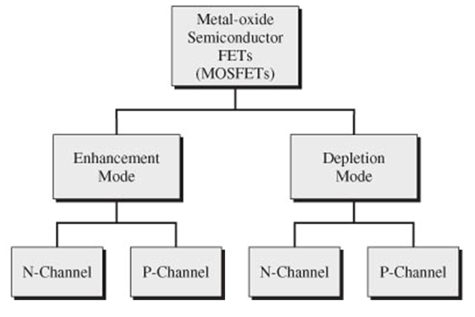
Figure 1: MOSFET classification
3.1 Enhancement mode MOSFETs (EMOS)
Enhancement mode MOSFETs don’t have a channel for current flow between source and drain. So when a voltage V_{DS} is applied across source and drain, current flows only if the gate voltage (V_{GS}) is large enough to create a conducting channel between source and drain by field effect. Otherwise the source and drain terminals are not connected.
3.1.1 EMOS operation regions
For an EMOS, with no bias voltage applied to the gate, two back-to-back diodes exist in series between drain and source. For an n-channel EMOS, one diode is formed by the pn junction between the n⁺ (heavily n-doped) drain region and the p-substrate, and the other diode is formed by the pn junction between the p-type substrate and the n⁺ source region. These back-to-back diodes prevent current conduction from drain to source when a voltage V_{DS} is applied. In fact, the path between drain and source has a very high resistance (of the order of 10¹² Ω).Therefore V_{GS} must possess a minimum positive threshold voltage (V_{t}) in order to create a conducting channel.
The operation of a MOSFET can be separated into three different modes, depending on the voltages at the terminals.
Cut-off or Sub-threshold or Weak Inversion Mode (V_{GS} < V_{t})
According to the basic threshold model, the transistor is turned off, and there is no conduction between drain and source. In reality, the Boltzmann distribution of electron energies allows some of the more energetic electrons at the source to enter the channel and flow to the drain, resulting in a sub-threshold current that is an exponential function of gate–source voltage.
Triode Mode or Linear Region or Ohmic Mode (V_{GS} > V_{t} and V_{DS} < (V_{GS} - V_{t}))
When V_{GS} is above V_{t}, the positive static charges accumulating at the gate electrode gain enough strength to attract electrons from nearby heavily n-doped regions and thus a conducting n-channel is created. Since such a channel is created out of a p-type substrate, the channel formed is termed as ‘inversion channel’ also. For a constant V_{GS} above V_{t}, V_{DS} appears as a voltage drop across the length of the channel. That is, along the channel from source to drain, the voltage increases from 0 to V_{DS}. Thus the voltage between the gate and points along the channel decreases V_{GS} at source end to V_{GS}-V_{DS} at the drain end. Since the channel depth depends on this voltage, the channel is not of uniform depth; rather, the channel will take the tapered form (refer to Fig.2), being deepest at the source end and shallowest at the drain end.

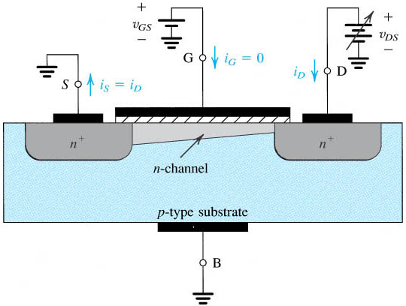

Figure 2: Enhancement mode MOSFET in Triode mode

As V_{DS} is increased, the channel becomes more tapered and its resistance increases correspondingly. Thus the I_{D} – V_{DS} curve does not continue as a straight line but bends as shown in Fig. 5 (appendix). So even though the region is named “linear”, the curve is not linear( particularly for V_{DS} values close to V_{GS}-V_{t}).
Saturation Mode or Active Mode (V_{GS} > V_{t} and V_{DS} > (V_{GS} - V_{t}))
When V_{DS} is increased to the value that reduces the voltage between gate and channel at the drain end to V_{t} __that is, V_{GS} -V_{DS} = V_{t}, or V_{DS} = V_{GS} – V_{t}__the channel depth at the drain end decreases to almost zero, and the channel is said to be pinched off. Increasing V_{DS} beyond this value has little effect (theoretically, no effect) on the channel shape, and the current through the channel remains constant at the value reached for V_{DS} = V_{GS} - V_{t} . The drain current thus saturates at this value, and the MOSFET is said to have entered the saturation region of operation. The voltage V_{DS} at which saturation occurs is denoted by V_{DSsat}. Obviously, for every value of V_{GS} ≥ V_{t}, there is a corresponding value of V_{DSsat.}.
3.1.2 p-channel EMOS
A p-channel enhancement-type MOSFET, fabricated on an n-type substrate with heavily doped p (p+) regions for the drain and source, has holes as charge carriers. The device operates in the same manner as the n-channel device except for the fact that V_{GS} , V_{DS} and the threshold voltage V_{t} are having negative values. Also, the current I_{D} enters the source terminal and leaves through the drain terminal.
PMOS technology originally dominated MOS manufacturing. However, because NMOS devices can be made smaller and thus operate faster, and because NMOS require lower supply voltages than PMOS, NMOS technology has virtually replaced PMOS. Nevertheless, it is important to be familiar with the PMOS transistor for two reasons: PMOS devices are still available for discrete-circuit design, and more importantly, both PMOS and NMOS transistors are utilized in complementary MOS or CMOS circuits, which is currently the dominant MOS technology.
3.2 Depletion mode MOSFETs (DMOS)
Depletion mode MOSFETs have a built-in channel connecting the source and drain (refer to Fig. 3). DMOS is a “normally on” device since there is no need to apply some threshold voltage at the gate terminal to induce a current carrying channel between source and drain.
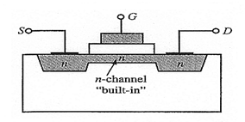
Figure 3: Depletion mode MOSFET

With an appropriate voltage applied between source and drain, current will flow through the channel, as a semiconductor resistance. However, when a negative voltage is applied to the gate for an n-channel DMOS, some negative static charge will accumulate on the gate. This negative voltage will repel electrons away from the gate. But free electrons are the majority current carriers in the n-type silicon channel. By repelling them away from the gate region, the applied gate voltage creates a depletion region around the gate area, thus restricting the usable width of the channel for current flow. The p channel DMOS transistor operation is the same as for the n channel DMOS transistor with the polarity of the gate voltage reversed.
Because this type of FET operates by creating a depletion region within an existing channel, it is called a depletion-mode MOSFET. Unlike EMOS, here an n-channel DMOS is having a negative threshold voltage V_{t}, which is also the cut-off voltage. When a V_{GS} ≤V_{t} is applied, all electrons in the n-channel will be repelled away from the gate and channel disappears. Thus I_{D} theoretically becomes zero. For positive V_{GS} voltage values, the DMOS will be in Enhancement Mode .DMOS current-voltage characteristics will be same as that of EMOS, except for the plot of drain curves for negative values of V_{GS}.
4. CMOS Circuits
The principal reason for the success of the MOSFET was the development of digital CMOS logic, which uses p- and n-channel MOSFETs as building blocks. Overheating is a major concern in integrated circuits since ever more transistors are packed into ever smaller chips. CMOS logic reduces power consumption because no current flows (ideally), and thus no power is consumed, except when the inputs to logic gates are being switched. CMOS accomplishes this current reduction by complementing every NMOS with a PMOS. A high voltage on the gates will cause the NMOS to conduct and the PMOS not to conduct and a low voltage on the gates causes the reverse. During the switching time as the voltage goes from one state to another, both MOSFETs will conduct briefly. This arrangement greatly reduces power consumption and heat generation.
5. MOSFET scaling
Over the past decades, the MOSFET has continually been scaled down in size; typical MOSFET channel lengths were once several micrometres, but modern integrated circuits are incorporating MOSFETs with channel lengths of less than a tenth of a micrometre. Intel began production of a process featuring a 65 nm feature size (with the channel being even shorter) in early 2006. ‘International Technology Roadmap for Semiconductors’ (ITRS) is the “roadmap” maintained by the semiconductor industry for describing forecasts and technology barriers to semiconductor device size reduction. The 2006 roadmap refers to devices with a physical gate length of 13 nm in size by the year 2013.
5.1. Need for MOSFET scaling
Smaller MOSFETs are desirable for several reasons. The main reason to make transistors smaller is to pack more and more devices in a given chip area. This results in a chip with the same functionality in a smaller area, or chips with more functionality in the same area. Since fabrication costs for a semiconductor wafer are relatively fixed, the cost per integrated circuits is mainly related to the number of chips that can be produced per wafer.

5.2. Difficulties arising due to MOSFET size reduction

Effect on transistor working as a switch

Because of small MOSFET geometries, the voltage that can be applied to the gate must be reduced to maintain reliability. To maintain performance, the threshold voltage of the MOSFET has to be reduced as well. As threshold voltage is reduced, the transistor cannot be switched from complete turn-off to complete turn-on with the limited voltage swing available.
Increased gate-oxide leakage
When MOSFET size is reduced, the oxide layer thickness also has to be reduced. For current gate oxides with the smallest thickness around 1.2 nm (which in silicon is ~ 5 atoms thick) the quantum-mechanical phenomenon of electron tunneling occurs between the gate and channel, leading to increased power consumption. The situation will worsen, if the device is scaled to lower dimensions. This problem can be solved upto an extent by increasing the dielectric constant of the gate oxide, which will reduce the tunneling phenomenon by increasing the capacitance. But for many of the SiO₂ alternatives, the energy gap difference between semiconductor and the dielectric will be low, tending to increase the tunneling current. This will negate the advantage of higher dielectric constant.

Heat production
The ever-increasing density of MOSFETs on an integrated circuit is creating problems of substantial localized heat generation that can impair circuit operation. Circuits operate slower at high temperatures, and have reduced reliability and shorter lifetimes.

6. Conclusion
MOSFETs are classified in to two; EMOS and DMOS, with each of them having it’s n-channel and p-channel derivatives. EMOS doesn’t have a built-in conducting channel and is a normally-off device whereas DMOS is a normally-on device due to the presence of the conducting channel. The MOSFET behaviour can be understood explicitly, by analyzing its I_{D}-V_{DS} characteristic curves. The three modes of operation give MOSFETs the ability to act as a switch or resistor. NMOS and PMOS differ in the polarities of the voltages applied and type of charge carriers. Owing to the valence band conduction, which is carried out close to the semiconductor nucleus, a PMOS operates much slower than an NMOS. Also, PMOS is physically larger and they require larger supply voltages to work efficiently. However, PMOS are still needed as they are utilized in discrete circuit design and CMOS circuits (along with NMOS). In order to create smaller chips, with more functionality per unit area, MOSFET size has to be scaled down. There is an ‘International Technology Roadmap’ to study the prospects of semiconductor device size reduction.

Appendix
A.1. Circuit symbols
 | Enhancement mode MOSFET | Depletion mode MOSFET
p-channel | 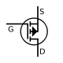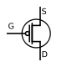 | 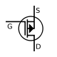
n-channel | 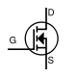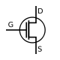 | 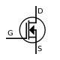
Figure 4: MOSFET symbols
A.2. I_{D} – V_{DS} characteristics
Figure: 5 shows the behaviour of V_{DS} – I_{D} curve for V_{GS} > V_{t}. It is the general curve for both DMOS and EMOS. Two regions can be marked in the curve: Triode region (Ohmic region) and Saturation region. In the Ohmic region, there is a linear relationship exists between I_{D} and V_{DS} for values of V_{DS} much less than V_{GS}-V_{t.}. That is, the transistor is behaving like a resistor in the Ohmic region. This value of resistance can be found out to be approximately
R_{DS (on)} = (V_{GS}-V_{t})/I_{DSsat} , where I_{DSsat} is the drain current at the Saturation region.
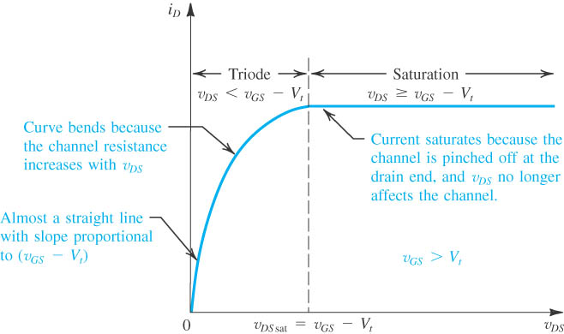
Figure 5: I_{D} – V_{DS} curve for MOSFETs

In the figure: 6, all three regions of operation of a MOSFET are shown. The curve behaviour is same for a DMOS or EMOS; except for the fact that V_{t} is negative for an n-channel DMOS (cutoff voltage will be negative). The transistor working as a switch can be explained based on this curve. When V_{GS} ≤ V_{t}, transistor will act as an open circuit (i.e., an open switch). If the circuit is configured in such a way that it would operate in the triode region for V_{GS}>V_{t}, then the transistor can be approximated to a short circuit (i.e., a closed switch).
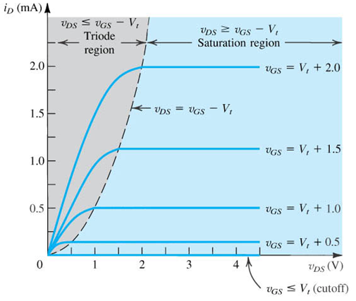
Figure 6: I_{D} – V_{DS} curve showing all three MOSFET operation regions
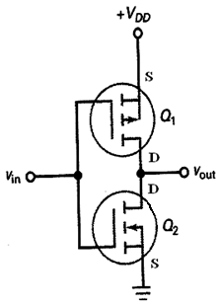
A.3. CMOS inverter
Figure: 7 shows a CMOS inverter. Here the upper transistor is a PMOS and lower one is an NMOS. When Vin is high, PMOS will be in cut-off mode. So the PMOS will act as an open switch and Vout will be low. When Vin is low, PMOS will be biased in the triode region and it will act as a closed switch. So the V_{DD} will come to the drain terminal of the NMOS. Since Vin is very low, the NMOS will be in cut-off mode. Thus, it will act as an open switch and Vout will become approximately equal to V_{DD} (which is a very high voltage). In both the above conditions, from PMOS source terminal to NMOS source terminal, the branch will be opened either at PMOS or NMOS. So the power dissipation will be low. However, while Vin is changing from high to low or low to high, there is a short interval of time, during which none of the transistors are opened. Then a short pulse of current will flow through the branch which will lead to some power dissipation.

Figure 7: CMOS inverter

Bibliography
- ITRS official website. January 14, 2008. September 21, 2008 < http://www.itrs.net>
- Malvino, A., Bates, D.J., “Electronic Principles, Seventh Ed.” Tata McGraw Hill, 2007
- “MOSFET”emag solutions. November 4, 2006. September 21, 2008 <http://www.usbyte.com/common/MOSFET.htm>
- "MOSFETs" Encyclopaedia Wikipedia Online. 2008. Wikimedia Foundation, Inc. September 20, 2008 < http://en.wikipedia.org/wiki/MOSFET>
- Sedra, A.S., Smith, K.C., “Microelectronic Circuits, Fifth Ed.” Oxford University Press, 2006

