Advertising stragtegy of ..


The brand ‘Fevicol’ – an introduction

The Fevicol story began in 1959, when the Parekh Group floated Pidilite Industries to capitalize on the potential market for synthetic resin adhesives, or “white glue” in India. Pidilite Industries decided to enter into adhesive or white glue market in the country which is primarily consumed in woodworking. The primary application of white glue was in woodworking, with secondary applications in upholstery, flooring, and footwear. Company decided to enter in to retail market with the product and for that, they come up with collapsible tube. Company came up with different packaging in order to cater to different segment of customers.
Pidilite Industries decided to leverage the Fevicol brand’s success and popularity by launching a version suitable for the retail market. The first product line extension, a 30-gram collapsible tube, was introduced in the early 1970’s. Subsequently the company rolled out a spate of uniquely packaged Fevicol products, available for school students as well as professional and educational institutions. The introduction of various packaging formats helped transition the brand from the image of an industrial product to an all-purpose glue.
The USP of brand is ease of applying it. Consistent quality, widespread distribution networks, and excellent customer relationships have been the key success factors for the Fevicol brand and knowing its strong brand equity, the brand will continue to be glued to the minds of Indian consumers.

It’s all about branding- The Brand FEVICOL
Few brands enjoy the status of being synonymous with the category of product they represent. Fevicol is one such brand. Sold in its signature blue and white packaging, this legacy brand is a generic name in the adhesive category in India, and is a familiar sight in most households. The product’s ease of application worked as a unique selling proposition for the brand; this was at a time when unwieldy natural adhesives (which needed to be melted before use) were the norm in the wood furniture making industry.
The brand’s reputation for its consistent focus on quality was propagated through word of mouth publicity, and has led to the brand enjoying a high level of trust among its target audience. Pidilite organized 'International Creative Contest' last year in which 800,000 students from 3000 schools participated. And 1000 schools introduced craft lessons in their schools. Brand Building/Brand Recall Made Easy.

Brand equity
Fevicol was ranked No. 1 in the Household Care segment of the Most Trusted Brands in India for 2007-08 by Brand Equity (The Economic Times) and overall has been ranked the 20th Most Trusted Brand. Pidilite, the makers of Fevicol, rank 131st among India’s Top 500 listed companies, including those in the private and public sector (ET 500, published by the Economic Times in March 2007). The brand has built strong brand equity over the years and is able to achieve so much success due to its consistent quality, efficient distribution network and CRM practices by the company.
Advertising strategy adopted by Fevicol
One of the main reasons for Fevicol's popularity is the creative marketing strategy, including successful advertising campaigns created by Ogilvy & Mather.
Fevicol advertisements over the years have always been remembered. Right from Bob Cristo wrestling with a chair made of Fevicol, to a politician who is glued to his chair, to the hen that laid unbreakable eggs, to the overflowing bus, to the joint family that refuses to fall apart, every piece of communication developed by Ogilvy & Mather has broken clutter, increased sales and at the same time entertained the viewer.
The Fevicol campaigns over the years have resulted in making it a 'numero uno' brand in a segment dominated by unbranded, unorganised, low involvement and low cost products. Two key drivers have made Fevicol a power brand:
- A continuously innovative approach to own 'bonding'
- Retaining the Indian flavour in the communication with a touch of humour.
Today, Fevicol owns the territory of bonding seamlessly. Today everyone asks for ‘Fevicol’ and not adhesive.
Connecting with carpenters
In its early years most competitors—small-scale local manufacturers of white glue and multinational brands like Movicol (currently discontinued)—marketed their products through hardware stores and timber marts. Fevicol, on the other hand, approached carpenters directly. This direct marketing initiative was one of the most successful strategies employed by the company and helped the brand gain a strong foothold in the white glue market.
Over the years, Fevicol has introduced a series of programs for carpenters and end-users to help build a strong relationship with them. Fevicol introduced Fevicol Furniture Books which showcased furniture designs with illustrations and measurements. These books helped enlighten the carpenters on new styles and trends in the furniture market, apart from building awareness for the brand. The Fevicol Champion’s Club (FCC) was another initiative introduced by the company. It served as a platform for carpenters to increase their social contacts and be part of a social network. The company went a step further by sponsoring activities to build relations with the families of the carpenters.

Connecting people with humour
Creative advertising has also helped keep the brand alive in this non-interesting category. The creative strategy that Ogilvy & Mather has employed for Fevicol is “to make bonding a Fevicol attribute,” and its advertising has used intelligent humour to convey this meaning.
Catch phrases from popular Fevicol TV ads like "Dum laga kar haisya, zor laga kar haisya"; "Fevicol ka majboot jodh hai, tootega nahi" and "Pakade rehna, chhodana nahi" are also used in day-to-day conversation. Fevicol and the other brands from Pidilite have received more than their share of space in the media as well.

Advertising by Fevicol- over the years
Change is good, but sometimes it's even better to remain impervious. The television ads for Pidilite Industries' Fevicol brand are a perfect example. When the corporates around were changing their adverts as often they changed their shirts, the Fevicol pitch remained unaltered for years, except for small tweaks here and there.
Giving it the unique brand image of ‘ultimate bonding’— the agency began with the ‘Dam laga ke haisha’ ad in 1989 and went on to create some memorable campaigns like the hen eating out of a Fevicol can laying unbreakable eggs (1998), or a man’s shadow refusing to follow him as it gets stuck to a Fevicol logo (2000) or that of an overloaded bus in a desert with people not falling off due to the Fevicol signage. All Fevicol ads are just our takes on how we observe life and are designed to make both the man on the street.
But why does Pidilite spend between Rs 10 crore and Rs 15 crore on advertising Fevicol which is not really a mass consumer product. The primary target consumers for the brand are interior decorators, carpenters, dealers and architects who can certainly be reached through more prudent ways. That is because Fevicol advertisements appeal to everybody. Besides the carpenters and architects, it is essential to talk to the household owners who influence the decision on purchase of adhesives. Besides, Fevicol and its brand extensions such as Feviquik, Fevistic, Fevitite are being used in schools, offices, households and do-it-yourself segments.
Initial advertising strategy- Connecting people through humor
Fevicol began its advertising stint by approaching carpenters directly. This direct marketing initiative was one of the most successful strategies employed by the company and helped the brand gain a strong foothold in the white glue market. Introduction of Fevicol Furniture Books which showcased furniture designs with illustrations and measurements enlightened the carpenters on new styles and trends in the furniture market, apart from building awareness for the brand.
Some of the famous TVC are discussed below.

- (1998)
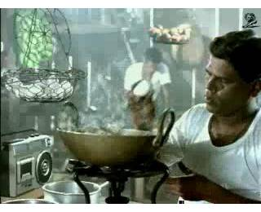

- (2002)
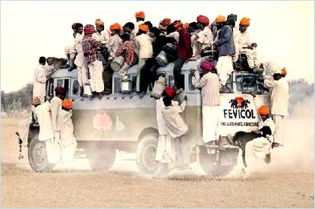

Print advertisements by Fevicol

Fevicol is one brand that has a consistent message, and executed quite well. The print ads had always been humorously creative. Here are some of the print advertisements by Fevicol.

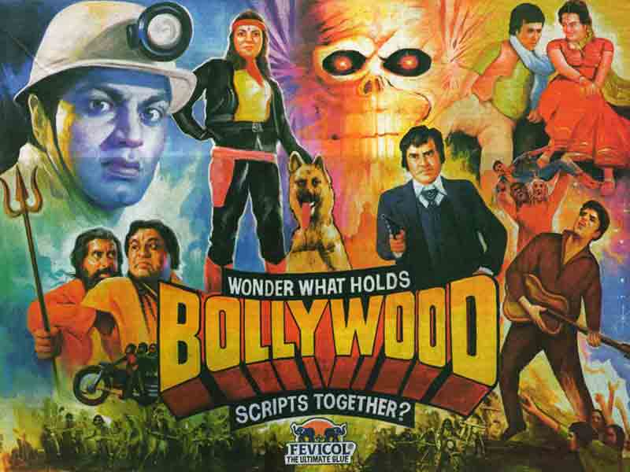

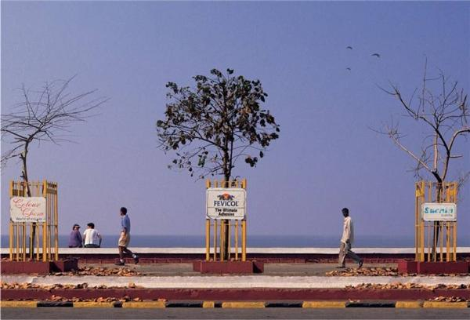

Ending note
Fevicol has penetrated the brand deep into the minds of the customers themselves. In the beginning it may be that there was not much competition, but now their innovative ads and marketing campaigns still keep them at that spot. Fevicol is a brand that’s so much into the Indian consumer’s psyche as Xerox and recently iPod is among the international audience. Fevicol, in existence since 1959, enjoys upwards of 60% market share and is manufactured and marketed by Pidilite Industries Ltd .
‘Yeh Fevicol ka mazboot jod hai, tootega nahi’ has been playing on the television for over two decades now. Ogilvy and Mather has a mix of 15 old and new ads, which are aired in rotation. In fact, the first Fevicol ad that was aired in 1988 is also shown now.

Madhukar B. Parekh, MD, Pidilite Industries has an innovative marketing strategy. The idea is to seek out every possible opportunity by 'swarming' sales channels and geographies to maximize penetration. For example Pidilite engages in direct marketing by publishing magazines and sending them to almost 300,000 carpenters every quarter. It conducts seminars and product awareness sessions with carpenters on a regular basis in various regions. Courses for housewives on the effective use of art material is another such initiative. Plus its ad campaigns also adhere to quality standards with cost effective media planning, resulting in high brand recall for Fevicol and M-seal. New campaigns are being planned for the new host of brands like Dr Fixit.

Perhaps, all the kudos go to the creative head. Here is a mundane thing: an adhesive. We don't think anyone prior to Fevicol would have actually thought of branding an adhesive. It seems like a low-involvement product. What does it matter what adhesive you use? Instead, Pidilite has an amazing number of funny and creative ads for this product, which is no doubt their flagship brand.

There is one thing you will notice in most (if not all) ads. They always have a rural setting/backdrop. The Indian rusticity is what stands out, and they have a generous dose of humour to support it! They borrow scenes or instances from daily life; whether it be the overcrowded bus; or some carpenters at work. And that is their best strategy. Especially involving the actual users of the product, like carpenters, in their ads. And it works for them even more, as they were the first to undertake direct marketing to carpenters; and not just hardware stores and timber marts, like their competitors. Now, Fevicol is almost a generic term for "adhesive" (or "glue"). And that is its biggest achievement. Not all products become generic to the product category. "Building Bonds" is what Pidilite's tag line says and that "bond" is what drives the creative messages. Even over the years, they have played around with the strength and have evoked in us the sense of what an adhesive is supposed to deliver - offer the best bond.... jo toot na paye!

Even the Fevicol logo, with the two elephants tugging at, what seems to be a ball stuck with Fevicol; or a piece of wood stuck with Fevicol, and still struggling is a sign of "mazbooth jod".

