CERTIFICATE OF ORIGINALITY OF WORK
This is to certify that Shri.Nagaraj.S.Patil has done project of design of hydraulically operated spring stiffness measuring machine. This project is assigned by me and he himself designed the machine and Original one.

DATE: - PROJECT GUIDE.

COMMENTS OF THE PROJECT GUIDE.

Shri. Nagaraj.S.Patil successfully completed the project work and he himself prepared the project report, drawn all the necessary drawing very neatly.

DATE: - PROJECT GUIDE.

“DESIGN OF HYDRAULICALLY OPERATED SPRING STIFFNESS MEASURING MACHINE”

A project report submitted in partial fulfillment of requirement for the award of Diploma in Mechanical Engineering from Institute of Government Polytechnic Belgaum.

SUBMITED BY.
Shri Nagaraj.S.Patil
UNDER THE GUIDANCE OF
PROF. UDAY.BASAPPA.KHADABADI, ME-058092/3.
KLE ENGINEERING COLLEGE.
BELGAUM-590008.

CONTENTS.
TITLE.
- Synopsis.
- Final project report.
- Brief description about project.
- Type of springs.
- Materials for helical spring.
- Materials for leaf spring.
- Hydraulic fluid.
- About equipment.
- Hydraulic circuit.
- Working principle.
- Specification.
- Design of various components.
- Power pack.
- Design of main frame.
- Design of Ram end thread.
- Design of Adjustable table screw.
- Design of hydraulic cylinder thickness, flange thickness.
- Design of end cover & seal box bolts.
- Design of table.
- Forward load & Return load calculation.
- Load/pressure graph for cylinder forward.
- Load/pressure graph for cylinder return.
- Cost estmatation,
- Catalogues.
1. Hand pump.
2. Lever operated D.C.valve.
3. Pressure relief Valve.

DRAWINGS.

- Machine Assembly Drawing.
- Machine Assembly M.L.
- Main Frame Fabrication.
- Table.
- Adjustable Table.
- Nut.
- Moving Adaptor.
- Pointer mounting.
- Pointer.
- Scale.
- Cylinder Assembly Drawing.
- Cylinder.
- End Cover.
- Ram.
- Piston head.
- Seal box.

1. SYNOPSIS.

- Title of the project: - Design of hydraulically operated Spring Stiffness Measuring Machine.

- Objective of the study: - Knowing the stiffness of the spring.

- Rationale for the Study: -

1. To know the Stiffness of any unknown spring.

2. In Spring manufacturing Industries quality checking.
3. Spring purchaser can check spring stiffness on this machine very
easily.
4. In educational institute this machine helps to compare the
theoretical design and practical spring stiffness.
- Detailed Methodology to be used for carrying out of the study: - Springs are used in machines for different purpose. Automatic lever return after removing the load, automatic hydraulic cylinder return, spring are used in die cushioning, In pressure relief valve, in shock absorbers, in between railway wagons, Automobile Industry various shapes and sizes of springs are used.
In Industries they purchase the springs for their machines. But they are facing the problem of checking the spring stiffness. Understanding the Industry people problems this simple machine is designed. Machine operation is simple. Only knowing the two readings, load and deflection we can calculate spring stiffness.

- Expected Contribution from Study: - This study helps to solve the problems of checking the stiffness of spring. This machine can be used in material testing laboratory as stiffness checking machine. Like rock well & Brinell hardness checking machines.

- List of activities to be carried out to complete the project:-
(With the help of a bar chart attached herewith showing time schedule)
Ref. Page No.7A.
- Places/Labs/Equipments and tools reqd. and planning of arrangements.
- Welding shop reqd.for welding main frame.
- Lathe machine reqd.for machining the components.
- Hand pump, Hand operated D.C.valve, pressure relief valve, pressure gauge reqd. These equipments are manufactured in Polyhydron Company Belgaum.
- I am working in Govt.ITI hence all tools and equipments are available.

- Problems envisaged in carrying out the project, if any:- NIL.

- FINAL PROJECT REPORT.

- Title of the Project: - Design of Hydraulically Operated Spring Stiffness measures Machine.
- Objectives of the Study: - Knowing the Stiffness of spring in shortest time.
- Methodology of the Study: -
1) Visiting the spring manufacturing company and knowing their stiffness checking problems.
2) Visiting to the spring users company and understanding their problems.
3) In so many educational Institute not availability of stiffness checking machine.

- Statement of the Problem: - Checking the stiffness of any spring.
- Input data/structure/Quaternaries: - Variety of springs.
- Analysis/Solution/Description: - After studying the problem facing by Industries for stiffness checking of spring then detail study is done how to solve the problem. Then one idea has come to use hydraulic equipment to solve this problem, hence hydraulically Operated Stiffness Measuring machine is designed.
- Final Results: - This machine is simple to operate, cost is low, table mounting type, less space reqd. Hence it can be used as laboratory equipment for stiffness checking.
- Conclusion: - Simple machine for spring stiffness checking.
- Scope of future study: - Cost can drastically reduced if it is mass manufactured.

3. “BRIEF DESCRIPTION ABOUT PROJECT”
Stiffness of the spring means load required for unit deflection, It is also known as spring index and is main parameter for specification of springs. Springs like Compression helical spring, Tension helical spring, Leaf spring of various sizes and shapes are designed and manufactured. But to check their stiffness is very difficult unless we have such machine.
Stiffness checking machine also useful in Engineering college, Polytechnics, for laboratory experiments. Stiffness checking machine is useful for spring manufacturer as well as spring purchasers for checking the stiffness. In Industry quality control department helps much more.
Considering wide application of machine this project is taken for design the simple machine.

- TYPES OF SPRINGS
Springs are classified according to their shapes.
- Helical springs.
- Compression Helical spring.
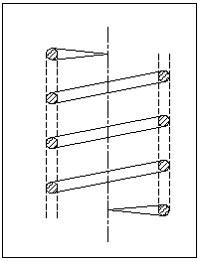 Fig.1, a
- Tension Helical spring.
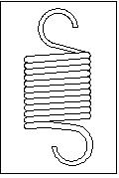 Fig.1, b
- Conical & Volute spring.
- Conical spring.
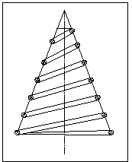Fig.2, a

- Volute spring.
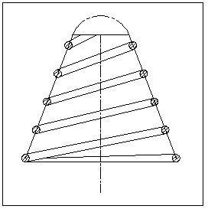 Fig.2, b
- Torsion springs.

- Helical torsion spring.
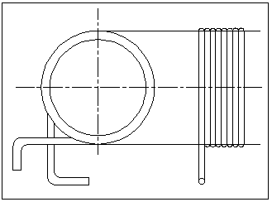 Fig.3, a

- Spiral torsion spring.
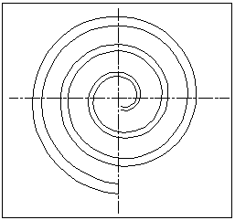 Fig.3, b

- Leaf spring.
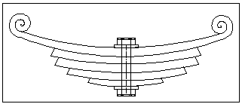 Fig.4
- Disc spring.
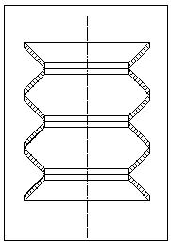 Fig.5

- MATERIALS FOR HELICAL SPRINGS.
The springs are mostly made from oil tempered carbon steel wire containing 0.6 to 0.7 % carbon and 0.6 to 1.0 % manganese. Music wire is used for small springs. Non ferrous materials like phosphor bronze, beryllium copper, Monel metal, brass etc. may be used in special case to increase the fatigue resistance, temperature resistance, & corrosion resistance.

- MATERIALS FOR LEAF SPRINGS.
The materials used for leaf spring is usually a plain carbon steel having 0.9 to 1.0% carbon. The leaves are heat treated after the forming process. The heat treatment of spring steel produces greater strength and therefore greater load capacity, greater range of deflection and better fatigue properties.
According to Indian standards the recommended materials are.
- For automobiles 50 Cr1, 50 Cr1 V 23, & 55Si2Mn90 all used in hardened and tempered state.
- For rail road springs: C55 (water hardened) C75 oil hardened,40 Si2Mn90 (water hardened ) and 55Si2Mn90 (oil hardened).
7. HYDRAULIC FLUID.
Hydraulic Medium: - Mineral Oil.
Viscosity range: - 10 CST to 380 CST.
Fluid Temp. Range- -20° C to +70° C.
Fluid cleanliness reqd: - As per ISO code 16/13 or better.
Oil Used: – ISO VG 68.
Viscosity – 68 CST @ 40° C.
Above property hydraulic oil is used in hydraulic cylinder to transmit the power. Assumed oil is incompressible.
8 .ABOUT EQUIPMENT .
In this machine helical spring, different cross sections, Tension spring, Leaf spring stiffness can be checked with suitable adapter. Design of machine is very simple and table mounting type for easy operation. Assembly drawing is as shown in fig. To adjust the different height spring moving table is provided to set the height and it can be locked by lock nut at suitable height.
Take the spring and measure its free length. Adjust the gap between moving adapter and adjustable table equals to free length of spring by rotating moving table. Keep the spring on center position of moving table and again adjust correctly. Then lock the moving table by tightening the lock nut.
Next set the pointer on then scale to ‘ZERO’ mark. Operate the hand lever of hand operated pump slowly. Ram descends and pr. Gauge starts to give reading.
Note the deflection by reading the pointer position. Then note the pressure again continue the some procedure to get still 4-5 readings.
Sl. No. | Pointer reading in mm (deflection) | Pr. Gauge reading in bar. | Load=Pr.G Reading X Bore area in m²  (W) | Stiffness= Load/deflection in N/mm.
Pressure gauge gives readings in Bar.

5
1 bar = 10 N/m²
A= Area of cylinder bare in m ².
Load = P x A.
= ------------ N.
Deflection=____________ mm.
Load
Stiffness =k= = ---------------- N/mm.
Deflection
For checking helical tension springs fix the eye bolts on top end bottom adapters. Tension spring hooks are located in eye bolt. Here also follow same procedure are said earlier to set the machine. Main difference in checking tension spring is load acting when piston while is returning. Hence while checking tension spring piston is taken required length at bottom position. Then adjust moving table and moving adapter to required height. D.C. hand lever should be suitably positioned.
Pressure gauge reading and pointer reading note in table as given bellow.
Sl. No. | Pointer reading in mm (deflection) | Pr. Gauge reading in bar. | Load=Pr.G Reading X annular area in m² (W) | Stiffness= Load/deflection in N/mm.
Pressure gauge reading in bar
5
1 bar = 10 N/m²
a = Annular area of the cylinder in m²
load = p x a
= ------------ N.
Deflection = --------------------- mm.

Load
Stiffness = k = = ---------------- N/mm.
Deflection
9 .HYDRAULIC CIRCUIT & ML.

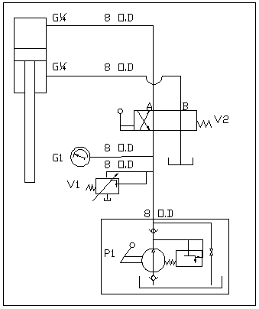

Sl. No. | Description | Make | Model | Qty.
P1 | Hand pump | Polyhydron | HP16 | 01
V1 | Pressure relief valve | Polyhydron | DPRH 06 T 04.315 | 01
G1 | Pressure gauge | Vicca | Ø 100 G ¼ Backconn | 01
V2 | Hand Optd. D.C. valve | Polyhydron | 4DL 10 T02 | 01
--- | 8 OD SDSS Tube | ___ | 8 OD X 4M | 01
--- | Pipe coupling | ------ | Suitable for 8 ODXG¼ | 01

10 .WORKING PRINCIPLE.

Fix the spring on machine adjust the moving table properly set the D.C.valve in proper position. Operate the hand lever of hand pump for giving the load ram approaches. Note the pressure gauge reading and deflection by reading pointer position on the scale. Calculate the load or after the load/pressure graph to know the load.
Stiffness = Load
Deflection.

Load
Q = N/mm.
Deflection

11.SPECIFICATION.

- Cylinder forward capacity = 78 KN.
- Cylinder return capacity = = 38 KN.
- Hydraulic cylinder used = Ø 63/45 mm.
- Stroke of piston rod = 200 mm.
- Cylinder bare area = 3.117x10^-3 m ² or 3117 mm ².
- Cylinder annular area = 1.5268x10^-3 m2 or 1527 mm ².
- Working height = 1100 mm.
- Mode of operation = Hand operated.
- Max Gap between top moving = 500 mm.
adaptor and adjustable table
- Max. Working pressure = 250 Bar.
- Adjustable table movement = 0-250 mm.
- Total weight of machine = 115 Kg.

- Overall size of the machine
Height = 2100 mm.
Width = 700 mm.
Depth = 900 mm.

12 .DESIGN OF VERIOUS COMPONENTS.
- Design of main frame.
- Design of ram/piston rod end threads.
- Design of adjustable table screw.
- Design of hydraulic cylinder.
- Design of table.
13 .POWER PACK.
Hand operated pump is used to deliver the high pressure oil. Heavy duty construction with hardened and ground piston. Renewable suction, delivery, relief and release valve parts. Integral relief and release valve. Collapsible hand lever for compact size and short hand movement at low pressure.
Max working pressure of pump is 350 Bar. But we are using at 250 Bar only. Oil tank capacity is 1.2 liter. Force required at the end of the hand lever at max pressure 400 N.(Approx). max of the pump 8.7 Kg.(without oil).Lever operated two position D.C. valve is used to forward and return operation of hydraulic cylinder. Adjustable pressure relief valve is fixed on machine frame. 100 mm diameter burden tube pressure gauge is used to measure cylinder pressure.

14. DESIGN OF MAIN FRAME.
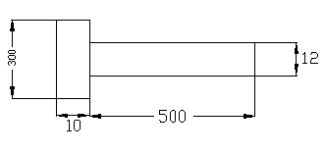
Area = (300x10) + (12x500)
= 3000 + 6000
= 9000 mm ².
Direct tensile stress (ft) = Load
Area
= 78 x 10³
9000
= 8.66 N/mm².
Within limit < 220 N/mm²
Direct shear stress.
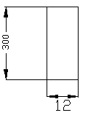

Shear area = 300x12
= 3600 mm².

Shear stress = Load = 78 x 10³
Shear force 3600
= 21.66 N/mm².
Within limit

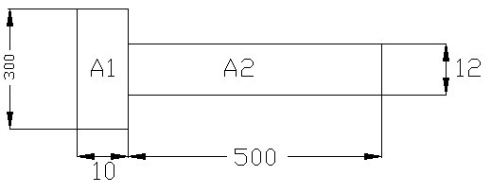
= A1 h1 + A2 h2 A1 = 300X10
A1+A2 = 3000 mm².
h1 = 10 = 5 mm
= 3000 X 5 + 5880 X 255 2
3000 + 5880

= 170.5 mm A2 = 490 X 12
= 5880 mm².
h2 = 10+490
2
= 10+245
= 255 mm

M.I. of the section about N.A.

I = b1d1 ³ + A1h ² + b2d2 ³ + A2h ²
12 12
= 300x(10) ³ + (300x10) x (165.5) ² + 12x(490) ³ + 5880 x (84.5) ²
12 12
= [ 25,000+82,170,750] + [ 117649000+41984,670]
= 82,195,750 + 159633670
6 4
= 241.8x10 mm

Zt = I
Yt 6
= 241.8 x 10
170.5
6
= 1.42x10 mm³

Zc = I
Yc 6
= 241.8 x 10
329.5
6
= 734x10 mm³

B.M = Load x distance

= 78x10³ x (200+170.5)
6
= 29x10 N-mm.

Tensile bending stress (fb) = BM
Zt
6
= 29x10
6
1.42x10
fb = 20.42 N/mm².

Compressive bending stress (fc) = BM
Zc
6
= 29x10
734x10³
fc = 39.5 N/mm².

Max. Tensile stress = Direct tensile (ft) + Tensile Bending Stress (fb)
= 8.66 + 20.42
= 29.08 N/mm².
Max. Comp stress = Tensile stress (fc) + Direct Tensile Stress (ft)
= 39.5 – 8.66
= 30.84 N/mm².

Stress at section YY.
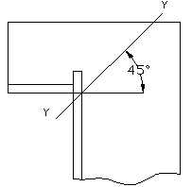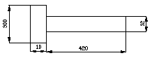

Area at section YY = (300x10) + (420x12)
= 3000 + 5040
= 8040 mm².

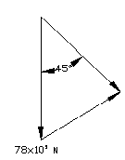 components of the load perpendicular to the section-yy.
= P cos 45°
= 78 x 10³ cos 45°.
= 55,154 N.

Tensile stress over the section fo = 55,154
8040
= 6.85 N/mm².

Component of the load parallel to the section-yy.
= P sin 45°
= 78 x 10³ sin 45°. = 55154 N.

Uniform shear stress over section-yy

fs = 55154 = 6.86 N/mm²
8040

Max tensile stress at inner corner.
ft = fb + fo
= 20.42+6.85
= 27.27 N/mm²

Max compressive stress at outer corner.
fc = fb + fo
= 20.42-6.85
= 13.57 N/mm².

Since the shear stress acts at right angles to the tensile and compressive stresses.

Max principal stress (tensile) on the section yy at the inner corner.

= ft + 1 (ft) ² + 4 (fs) ²
2 2

= 27.27 + 1 (27.27) ² + 4 (6.86) ²
2 2

= 13.63 + 15.26.

= 28.89 N/mm². < 220 N/mm².
Allowable yield stress

Max principal stress (compressive) on section-yy at outer corner.

= fc + 1 (fc) ² + 4 (fs) ²
2 2

= 13.57 + 1 (13.75) ² + 4 (6.86) ²
2 2

= 16.43 N/mm².

Max shear stress = ½ (ft) ² + 4 (fs) ²

= ½ (27.27) ² + 4 (6.86) ²

= 15.26 N/mm².

15. DESIGN OF RAM END THREADING.

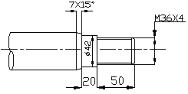

For M36x4 thread stress area = 817 mm²

Max. Return load = 25 KN.
Load
ft = stress area

25 x 10³
=
817

= 30.6 N/mm².

Max. Return load = 25 KN.

Load
fs =
II d x t

25 x 10³
=
II x 31.093 x 50

= 5.11 N/mm².

16. DESIGN OF ADJUSTABLE TABLE SCREW.
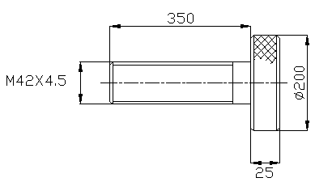

For M42x4.5 thread stress area = 1104 mm²

Max. Forward load = 78 x 10³ N.

Load
fc =
Stress area

78 x 10³
=
1104

= 70.65 N/mm².

Checking for shear stress Nut/Screw. Dc = 36.416 mm.

Load
fs =
II d x t

78 x 10³
=
II x 36.416 x 25

= 27.27 N/mm².

17. DESIGN OF HUDRAULIC CYLINDER.
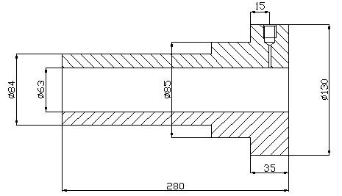
di = 63 mm.
= 6.3 cm.
ri = 3.15 cm. = 31.5 mm.
p = 250 bar.

5
= 250X10 N/m²

5
= 250X10 = 25 N/mm².
1000X1000
200
fi =
F.S

F.S = 2

200
fi = = 110 N/mm²
2
do = Outer diameter of the cylinder
We know that thickness of cylinder.

t = ri ft + p – 1
ft - p

= 31.5- 110 + 25 - 1 = 8.2 mm. < 10.5 mm.
110-25 Hence design is safe.

DESIGN OF HUDRAULIC CYLINDER FLANGE.

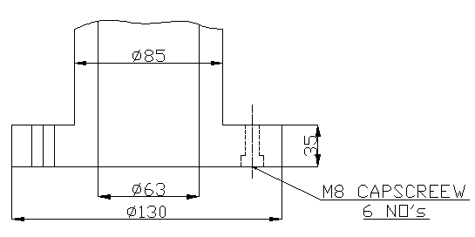

Ø 85 is location diameter.
Flange under shear
Load = 78 X 10³ N.
Shear area = π Dt.
= π X 85 X35
= 9,346 mm².
Shear stress = Load
Shear Area

= 78X10³
9,346
= 8.34 N/mm². < 135 N/mm² Yield shear strength.
NOTE: Because of cylinder connection flange thickness is taken more.

DESIGN OF CYLINDER ROD or RAM.
Load = π x di² x p
4
= π x (6.3)² x 25
4
= 77,931 N
~ 78 KN.
Stress on piston rod = Load

Area
Let d = 45 mm.
= π x (45)²
4
= 1590 mm².
Stress in piston rod = 78 X 10³ = 49 N/mm² < 220 N/mm².
1590
Hence design is safe.

18. DESIGN OF END COVER.
Let tc = Thickness of the end cover.

We know that p = di x tc x ft.

Let ft = 40 N/mm² (Assumed)

P = di x tc x ft

78 x 10³ = 63 x tc x40

tc = 78 x 10³

63 x 40

= 30.95 mm.
Say = 31 mm. < 45 mm
Design is safe.

DESIGN OF SEAL BOX FIXING BOLTS

M10, 8 No’s are used.

For M10 bolts Stress area = 58.3 mm².

Load = 78X10³ N.

ft : - tensile stress induced in each bolt = Load
8 x stress area of bolt

= 78 x 10³

8 x 58.3

= 167.2 N/mm². < yield tensile strength 220 N/mm².

19. DESIGN OF TABLE.
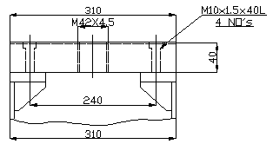

6
BM = wl = 78 x 10³ x 240 = 4.68X10 N-mm.

4
b = 310-42
= 268 mm.
t = 40mm.

Z = 1 bt²
6

Z = 1 X 268 X (40)²
6
= 7,1466 mm³.
6
Bending stress fb= m = 4.68X10
2 7,1466
= 65.48 N/mm². < 220 N/mm².
Hence design is safe.

DEFLECTION OF TABLE

D = w l ³ I = bd ³

48 E I 12
4
= 78 x 10³ x (240) ³ = 268 X (40) ³ = 1,429,333 mm
6 12
48x0.21x10x1,429,333

= 0.075 mm. Deflection is very less.

20. FORWARD LOAD & RETURN LOAD CALCULATION.
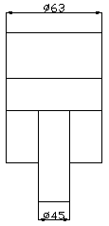
Cylinder used Ø 63 45 mm.

Main bore area = π x d²
4
π x (0.063)²
4
-3
= 3.117x10 m²

Annular area = π x D² - d²
4
= π x 0.063² - 0.045²
4
-3
= 1.5268 x 10 m².

Working pressure max. = 250 bar
Forward load = main bore x pressure.
-3 5
= 3.117x10 x 250 x 10

= 77,925 N.

= 78 KN.
-3 5
Return load = 1.5268x10 x 250 x 10

= 38.17 KN.
21. LOAD/PRESSURE GRAPH FOR CYLINDER FORWARD.

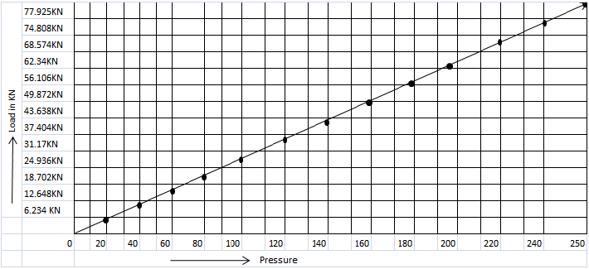

For compression spring checking Load/Pressure Graph.
By referring the above graph forward load is easily understood at different pressure.

22. LOAD/PRESSURE GRAPH FOR CYLINDER RETURN.

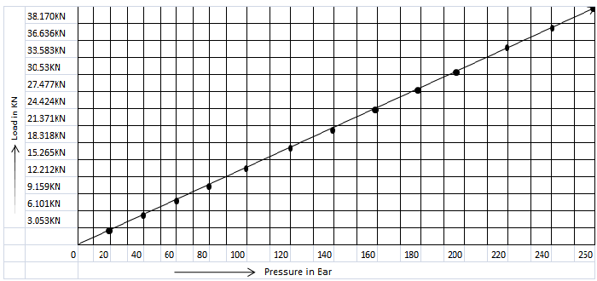

Tensile spring checking Load/Pressure graph.

23. COST ESTIMATION.

- Cylinder ______________ 3950
- Power pack _____________ 1450
- D.C.Valve ______________ 1250
- Relief valve ______________ 550
- Pressure gauge __________ 525
- Oil 2 Liter _______________ 160
- Coupling _______________ 240
- Pipe (SDSS)_______________ 240
- Main frame (fab.)__________ 5100
- Machining cost ___________ 2000
- Accessories_______________ 3000
- Assembly,pipping,__________ 1500
Painting & labour cost
TOTAL - Rs. - 19,965 /-

