Business research methods Project
ON

Health Food Drinks

Table of Contents

- Problem Definition…………………………………………………………………....4
  - Background……………………………………………………………………4
  - Statement………………………………………………………………...........4

- Literature Review………………………………………………………......................5

- Approach to the problem……………………………………………………........ …11

- Research design...........................................................................................................13
  - Preliminary investigation…………………………………………………….14
  - Collection of Quantitative Data……………………………………………...14
    - Measurement and Scaling Procedures
    - Questionnaire Design
    - Survey
  - Sampling Process………………………………………………….................15
    - Target population
    - Sample Size
    - Sampling technique

- Fieldwork………………….…………………………………………………………15

- Data Interpretation and analysis ……………………………………………………..16
  - Data Analysis Plan…………….……………………………………………16
  - Methodology………………………………………………………………..18
  - Analysis and Interpretation………….......………………………………… 19

- Results ……………………………………………………………………………….28

- Limitations and caveats ………………………….…………………………………..29

- Exhibits………………………………………………………………………………31

- References……………………………………………………………………………54

List of Exhibits

Exhibit 1: T-test on the influencing factors ……………………………………………..31
Exhibit 2: T-test on the influencing factors in families with kids ……………………….31
Exhibit 3: T-test on importance of product attributes …………………………………...32
Exhibit 4: One way Anova of product attributes vs different income groups…………..33
Exhibit 5: One way Anova of product attributes vs different education groups………..34
Exhibit 6: One way Anova of product attributes vs different age groups………………35
Exhibit 7: One way Anova of product attributes vs different family size groups……….37
Exhibit 8: Factor Analysis of Product Attributes/Considerations……………………….38
Exhibit 9: Cluster Analysis on Demographic Variables…………………………………41
Exhibit 10: T-test of different brands on different product attributes……………………41
Exhibit 11: Overall Perceptual Map……………………………………………………..45
Exhibit 12: Value-Seekers Perceptual Map……………………………………………...46
Exhibit 13: Quality-Seekers Perceptual Map…………………………………………….47
Exhibit 14: Anova test for checking brand loyalty of different brands………………….48
Exhibit 15: Brand Personality Map………………………………………………………49
Questionnaire…………………………………………………………………………….50

I. Problem definition

1.1 Background

India, the world’s largest malt-based drinks market, accounts for 22% of the world’s retail volume sales. These drinks are traditionally consumed as milk substitutes and marketed as a nutritious drink, mainly consumed by the old, the young and the sick.
The Health food drinks category consists of white drinks and brown drinks. South and East India are large markets for these drinks, accounting for the largest proportion of all India sales. The total market is placed at about 90,000 ton and is estimated to be growing at about 4%. These Malt beverages, though, are still an urban phenomenon.
White drinks account for almost two-thirds of the market. GSK Consumer Healthcare is the market leader in the white malt beverages category with a 60.7% overall market share. Heinz’s Complan comes in second (in this segment, third overall) with a market share of 12-13%. Market leader GSK also owns other brands such as Boost, Maltova and Viva.
Currently, brown drinks (which are cocoa-based) continue to grow at the expense of white drinks like Horlicks and Complan. The share of brown drinks has increased from about 32% to 35% over the last five years. Cadbury’s Bournvita is the leader in the brown drink segment with a market share of around 15%.
Other significant players are Nestlé’s Milo and GCMMF’s Nutramul.

1.2 Problem Statement

The project had been undertaken with an objective to understand the customer behaviour in the “Health Food Drink (HFD)” product category. The objective of the study also included identifying the determinant purchase factors, the customer segments and the sources of information they rely on. The existing positioning of prominent brands and the perceptions among different segments were also covered under the study. The brand loyalty and switching were also studied. The brand personality was also studied as a part of the project.
II. Literature review

Nutrition In India
After 4 years of age, a child's energy needs per kilogram of bodyweight are decreasing but the actual amount of energy (calories) required increases, as the child gets older. From 5 years to adolescence, there is a period of slow but steady growth. Dietary intakes of some children may be less than recommended for iron, calcium, vitamins A and D and vitamin C, although in most cases -as long as the energy and protein intakes are adequate and a variety of foods, including fruit and vegetables, are eaten- deficiencies are unlikely.
Regular meals and healthy snacks that include carbohydrate -rich foods, fruits and vegetables, dairy products, lean meats, fish, poultry, eggs, legumes and nuts should contribute to proper growth and development without supplying excessive energy to the diet.
Children need to drink plenty of fluids, especially if it is hot or they are physically active. Water is obviously a good source of liquid and supplies fluid without calories. Variety is important in children's diets and other sources of fluid such as milk and milk drinks, fruit juices can also be chosen to provide needed fluids.

In India, each State is practically equivalent to a country with its specific socio-economic level, different ethnic groups, food habits, health infrastructures and communication facilities. Thus, the nutritional status of the population shows significant variation between states since it results from a varying combination of factors.
In the last 20 years, there has been an improvement in the nutritional status of the Indian population. This improvement results from not only changes in food intake but also socio-economic factors, increased availability of potable water, lower morbidity and improvement of health facilities.

In children under five years of age, the marked improvement in nutritional status is shown by the reduction of the prevalence of underweight from 63%, in the 1975-79 period to 53% in the 1988-90 period. The under-five mortality rate (U5MR), an important indicator of the socio-economic development, and health and nutritional status of a society, declined from 282% in 1962 to 115‰ in 1994. However, a multitude of infectious diseases such as respiratory and intestinal infections as well as malaria remain the main cause of death in children under five, with malnutrition being an aggravating factor. Measles, tetanus, typhoid and hepatitis are also frequent causes of death during infancy and childhood.

In the last 20 years, there have been no significant changes in patterns of dietary intake. Cereals remain the staple food in India providing most of the energy intake. Since the seventies the consumption of foods like pulses, roots and tubers has fallen, while those of other foods like sugar, "jaggery" (unrefined brown sugar), fats and oils and green leafy vegetables have slightly increased. The average Indian diet remains largely deficient in green leafy vegetables, meat, and fish, milk and milk products. Moreover, it also remains deficient in some micronutrients such as vitamin A, iodine and iron.

Adolescents who are undergoing rapid growth and development are one of the nutritionally vulnerable groups who have not received the attention they deserve. In under-nourished children rapid growth during adolescence may increase the severity of under-nutrition. Early marriage and pregnancy will perpetuate both maternal and child under-nutrition. At the other end of spectrum among the affluent segment of population, adolescent obesity is increasingly becoming a problem.

Pre-school children constitute the most nutritionally vulnerable segment of the population and their nutritional status is considered to be a sensitive indicator of community health and nutrition. Over the last two decades there has been some improvement in energy intake and substantial reduction in moderate and severe under- nutrition in pre- school children

India has enormous under-nutrition and over-nutrition problems
Asia has the largest number of malnourished children in the world. The Double Burden of Malnutrition in Asia was inspired by the massive challenge that this situation currently poses for Asia. It describes the main driving forces behind the groundswell of under-nutrition, while shedding light on the emerging double burden of co-existing underweight and overweight, and the linkages between these two different forms of malnutrition.

There are two types of nutritional problems - one is under-nutrition and another is over-nutrition. Emphasis should be given not only to food but also to care and health, the reason being that even if children in the age group of 0-2 years are able to get food, they may have mothers who do not have enough time to pay attention to their children. Similarly, if there is no health-guaranteeing environment, and children suffer from diarrhoeal diseases, no amount of food will help prevent malnutrition.

Over-nutrition, on the other hand, means either too many calories or the wrong types of calories such as saturated fats or highly processed sugar that lead to obesity, vascular diseases, etc. Many developing countries have under-nutrition and those in Europe and North America have over- nutrition problems. There is this in-between category with countries like India that still have an enormous amount of under-nutrition and significant over-nutrition problems. In India, for instance, around 50 per cent of its children under the age of five are undernourished or malnourished. But in urban areas, the over-nutrition problem is shooting up, thanks to the change in lifestyle and food habits. As a result, health systems are under huge stress.

When there is malnutrition, there is a higher level of lower birth rate. One in three babies born in India weigh significantly low because their mothers are undernourished. Some low-weight babies die and some survive and those who survive adapt to malnutrition and scarcity. That is, the biological adaptation is programmed to maximize every calorie the body gets. This adaptation that helped a malnourished baby survive suddenly turns out to be a mal-adaptation when the baby becomes an adult. The adult, who was malnourished in the past, gains extra weight even when he takes only normal amount of food because of the biological adaptation.

Brand Loyalty
Selling to brand loyal customers is far less costly than converting new customers (Reichheld 1996, Rosenberg and Czepiel 1983). In addition, brand loyalty provides firms with tremendous competitive weapons. Brand loyal consumers are less price sensitive (Krishnamurthi and Raj 1991). A strong consumer franchise gives manufacturers leverage with retailers (Aaker 1991) 1. And, loyalty reduces the sensitivity of consumers to marketplace offerings, which gives the firm time to respond to competitive moves (Aaker 1991) 1. In general, brand loyalty is a reflection of brand equity, which for many businesses is the largest single asset.

Perhaps the most cited conceptual definition of brand loyalty comes from Jacoby and Chestnut (1978, p. 80): “The biased, behavioral response, expressed over time, by some decision-making unit, with respect to one or more alternative brands out of a set of such brands, and is a function of psychological (decision-making, evaluative) processes.” Consistent with this definition are two broad categories of operational definitions. The first stresses the “behavioral response, expressed over time”—typically a series of purchases. As Day (1979) observed, however, the major limitation of behavioral measures is the failure to identify motive and the resulting confusion between brand loyalty and other forms of repeat buying. The major alternative operational definition is based on consumer attitudes, preferences, and purchase intentions. These measures stress the cognitive “bias,” and the “psychological (decision-making evaluative) processes” underlying loyalty.

Health Related Expenses
KSA TECHNOPAK has conceived an innovative product called Health Outlook 2003, which provides strategic insights to consumer shopping and buying behavior. Apart from the consumer insights, complete health profiling is also done for providing derived disease incidence and prevalence in the country.

This Pan Indian research model provides large research depths by covering about 10,000 households across cities like Chandigarh, Delhi, Jaipur, Lucknow, Ludhiana, Calcutta, Patna, Bangalore, Chennai, Cochin, Hyderabad, Madurai, Ahmedabad, Indore, Mumbai, Nagpur, Pune and Surat. The rich respondent profile includes SEC A, B and C giving a good coverage for demographic types.

Health Outlook shows that health enjoys about 9.4 per cent share of the wallet of Indian consumer and is on the rise for the last three years. This spend includes health supplements, health drinks, doctors and consultants fees, medicines, medical insurance, regular check ups etc.

About 91 per cent of this was out-of-pocket expense and only 9 per cent came from employers and insurance. Analysis of the consumer’s drug purchase behaviour shows that 59 per cent use old prescriptions and 29 per cent use over-the-counter drugs, meaning 88 cent of the consumers indulged in self-medication.

Consumer attitudes to health drinks are mainly influenced by quality attributes. Ethical factors are important in some cases, but they may be overstated. The relationships between consumers' awareness of health drink, price and perceived quality of food were investigated by tests involving series of consumer panels and sensory evaluation. Sensory responses were also matched to instrumental analysis data. Results indicated that overall there was no relation between panelists views about health drinks and their sensory perceptions. Eighty percent of the panelists felt that organic products were too expensive, but would buy them if they were cheaper. However the study showed that most of the people would not be likely to change their preference once they had made a product choice based upon sensory attributes. This has important implications, indicating that not only price, but also sensory quality of health drink must be considered in order to maintain repeated purchases by most consumers.
It is widely accepted that consumer acceptance of drinks is mainly determined by their sensory perception, while choice is strongly influenced by the perceived value for money. Ethical factors are important in some cases, but they may be overstated. Although comparisons between organic and conventional drinks have been reported for a range of attributes, measures of the quality of health drinks as perceived by consumers using objective sensory evaluation methods, or the relevance of any preconceptions in perception have not been studied. This study aimed to investigate the relationship of objective quality measurements including sensory attributes and consumer perception of organically and conventionally produced health drink products.

About two thirds of the consumers that participated in the survey believed that health drink is good for the environment, and 55% thought that it is healthier. However there was some confusion relating to the use of pesticides and chemicals in that. Few consumers’ distinguished health drinks by appearance or taste. Buyers of health drinks were more likely to indicate that the appearance and taste are better, but environmental protection was still the dominant perceived benefit. Buyers who believe that health drink is better also think that it is expensive (p<0.05). In this study, 80% of the consumers perceived health drinks to be too expensive (49% were non-buyers and 31% buyers)

II. Approach to the problem

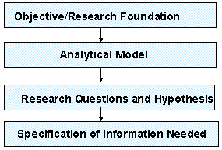

Objective or theoretical framework
The objective of this research is to identify the factors that influence a person into making a decision to buy a certain brand of malt-based health drink.
As mentioned in the Literature Review, according to industry analysts, this category has grown only on promotions and for now, except for promotions, nothing seems to be working. Therefore, ideally, this research should be able to bring to the fore, certain other factors that could lead to a growth of this segment.
At the very least, the research should corroborate the existing assumptions regarding the influencing factors. It should be in a position to verify that the steps various players are taking to stimulate volumes are in the right direction, and would eventually lead to an increase in market share.

Research Questions
- What are the different “Customer Segments” depending upon the preferences?
- What is the perception of people towards the leading brands of Health Food Drinks?
- What are different factors that influence the customer when He/She buys a Health Food Drink?
- Who are the major Influencers in the purchase decision of Health Food Drinks?

Identification of information needed
After fixing the objective, we started an extensive reading on the topic. The very first question we needed to clear in our mind was: “What does Health Food Drinks mean?”
Therefore we narrowed down to the malt-based Health drinks like Bournvita and Horlicks.
The subsequent readings helped us understand the consumer patterns and perceived needs of the consumers from a health drink. Depending upon that, we listed down several factors that can influence a consumer in buying or not buying a health drink.
The study on “Consumer Behaviour” throws light on the prevalent consumer purchase influencers like Price, Nourishment, Palatability, and Packaging which are included in the purchase influence factors in the questionnaire
The Literature on “Indian Nourishment” shows that the Indian consumer is getting more and more health conscious and thus there is huge potential for the health drinks in the Indian market.
Nowadays there can be a number of sources that influence a family in buying a Health Drink. These sources can be promotions, Doctor’s Advice, Peer Group talks ( word of mouth) and choice of the children themselves.
Since the malt-based health-drink segment is broadly divided into 2 categories - brown (cocoa–based) and white, therefore it was decided to study the leading brands available in both these categories. We visited retail outlets in different parts of South Delhi to determine the most popular brands. We have assumed that brands that are most visible and widely available are the most popular, as retailers would stock only those brands that invoke maximum sales
All identified factors were discussed and screened by the research team. In this process, factors that did not convey much, did not sound authentic or did not differ much from other factors were eliminated.

III. Research Design

The methodology followed for analyzing the consumer behavior of health food drink customers is as shown in the figure.
Preliminary Investigation
Secondary data analysis
Qualitative research
Collection of Quantitative data
Measurement and Scaling Procedures
Questionnaire Design
Survey

Sampling Process
Target population
Sample Size
Sampling technique
Plan for Analysis of Data
Factor Analysis
Cluster Analysis
Multi-dimensional Scaling
ANOVA

Field Work

3.1 Preliminary Investigation
This phase involved preliminary investigation of the various factors which could possibly affect the consumer’s perception about the various brands and in turn influence the purchase decisions of the consumer. We primarily used three methods to identify the various factors. The Secondary data gathered was analyzed to understand the current scenario of the Health drinks segment. The analysis of the secondary data also helped us find different attributes which affect the health drinks segment.

  - Collection of Quantitative data
Measurement and Scaling Procedures: Non-Comparative Rating scale is used in which respondents evaluate only one object at a time, and for this reason noncomparative scales are often referred to as monadic scales. Noncomparative techniques consist of continuous and itemized rating scales.
We have used continuous rating scale in order to rate the choices for purchase considerations and the sources of purchase decisions.

Questionnaire Design: This phase involved the design of the questionnaire on the basis of the potential factors identified as influencing the customer behavior. Research problems were listed and then the information needed was identified. The questions were then prepared in order to fulfill the information requirements as identified earlier.

Survey: Different Survey methods were used for collection of data. The principle method used was Personal Interviewing of the respondents. In-Home interviews were conducted by us at various locations in Delhi. We also did Mall Intercept at popular markets like Sarojini Nagar and Malviya Nagar. Due to the shortage of time, we conducted a few telephonic interviews to maintain diversity in data.

  - Sampling Process

Target Population: The target population is the collection of elements or objects that process the information sought by the researcher and about which inferences are to be made. Our target population involves the users, deciders and buyers of health food drinks. The users include the old and the young population. The deciders and the buyers mostly include the house wives who buy the product from the market.

Sample Size: It denotes the number of elements to be included in the study. Due to time constraints the sample size chosen is very small.

Sampling Technique: A mixture of quota and stratified method was used for sampling, with care being taken to get responses from customers of different age groups and different family sizes.

iv. Fieldwork

The survey was conducted keeping in mind the users and deciders of the health drinks. The survey was conducted in the Paschim Vihar and Ranibagh Areas of Delhi. We made several trips to the local market (Sarojini Nagar and Malviya Nagar) and the nearby households to gather information from relevant people.

V. Data Interpretation and Analysis

5.1 Data Analysis Plan

This chapter shows how the information needed to answer the three key research questions have been extracted via the questionnaire.

Q1 explicitly asked the respondents if a health drink is used in the family or by them. The questionnaire was not administered to the respondents that answered NO to this question. Such respondents have not been included in the sample size of 60 that has been mentioned.

Q2 to Q6 of the questionnaire are used to get the general details about the respondent (age, educational qualification, annual income, family size and number of children in the family. Q4 explicitly asked the respondents about the size of the family and Q6 asked about the number of children in the respondent’s family.

Q7 explicitly asks the brand preference of the respondent about the health drink.

Q8 asks the respondents to rate the importance of the following purchase considerations on a scale of 1(Very unimportant) to 5 (Very Important):

- Nourishment
- Colour
- Palatability
- Economy
- Shelf-presence
- Packaging
- Brand Image
- Promotions

These attributes were decided after a thorough secondary data analysis. However some of these attributes might have similar effect on the consumer preference. Therefore we conduct a factor analysis to find out the factors to which one or more of the above variables belong.

Q9 asks the respondents to rate the Sources of Information influencing the Purchase Decision. The following sources were considered:
  - Advertisement
  - Children
  - Doctor
  - Family
  - Past experience
  - Retailer
  - Word of mouth
The respondents were asked to rank the factors in order of importance.

Q10 ask the respondents to score each of the brands on the various product attributes on a scale of 1 – 5.
Five major selling brands were tested on the various product attributes mentioned. The brands included in the test were:
- Boost
- Bournvita
- Complan
- Horlicks
- Milo

Q11 and Q12 are used to determine the brand loyalty of the respondent towards the health drink, thus asking the switching pattern of the users.

Q13 in the Questionnaire attempts to find the Brand Personality by asking customers the perceived traits of each of the leading brands of health drinks available in the market today. It is very important to realize that these are not the attributes that the drink claims to possess, via its advertisements and other promotional activities. For e.g. Boost in it’s campaign claims that “Boost is the secret of my energy”, but rather the attributes the customer feels that the drink possesses. Therefore, if respondents identify spiritedness with Boost it would imply that Boost is successful in its marketing strategy. The responses to this question would also be important to other players in this segment, as they would realize that their promotions are not being effective and hence this would encourage them to redirect their marketing efforts. Apart from spiritedness, the other important traits have been identified as Modesty, Honesty, Cheerfulness, Boldness, Spiritedness, Reliability, Sophistication, Toughness, and Ruggedness.

5.2 Methodology

Questionnaire Checking/Editing: The questionnaire is checked for completion and interviewing quality. Editing is the review of the questionnaire with the objective of increasing accuracy and precision.

Collation of Data: The data is collated in the excel sheet and prepared for statistical analysis. An SPSS view of the data was also taken for further analysis.

Choice of Statistical Analysis Techniques:

T-statistic: A t-test was conducted on the results of the survey in order to compare the means of the ranks for the factors or sources of information to find out the most important influencing the purchasing decision. T-test was also conducted on the various product attributes for different brands.

Anova: It is carried to study the variance of the factors or product attributes that influence the most among the various demographic groups by conducting the one way Anova test on the scores of these 8 factors.

Factor Analysis: The various variables that denote the product attributes that determine the purchasing decision can be actually factored using factor analysis. This factoring of the variables helps in easily studying the consumer behaviour.

Cluster Analysis: The set of respondents was segmented on the basis of the demographic information namely ‘age-group’, ‘income-group’, ‘education’, ‘family size’ etc using cluster analysis so as to identify the distinct clusters depending upon these demographic factors.

Multi Dimensional Scaling: This analysis was performed on the overall samples as well as on the 2 segments individually so as to gauge the difference in their perceptions. The selection process depends on the fact that it is conducted on the aggregate level data, i.e. that on the two clusters formed after cluster analysis. This is due to the fact that all market strategies are typically formulated at the segment or aggregate level.

5.3 Analysis and Interpretation

Sources of Information influencing the Purchase Decision

  - Advertisement
  - Children
  - Doctor
  - Family
  - Past experience
  - Retailer
  - Word of mouth
The respondents were asked to rank the factors in order of importance. A t-test was conducted on the results of the survey in order to compare the means of the ranks for the factors. The results of the test are as shown in the Exhibit 1. We can say from the results that there is a significant difference between the ranks of the factors with a 95% confidence.
The two most important factors that emerge out of the tests overall are the “Family doctor” and the influence of the “Family”. This finding is an important implication for product placement. We can say that the health food drinks should appeal to the complete family rather than only a particular age group. Doctors can also be an important influencer or opinion leader and hence should be targeted in the product promotions. Some products have been promoting their products using comparative advertisements including testifications by the doctors.
A second test can be conducted in the same manner taking only the cases where the people are having kids in the family. The results are shown in the Exhibit 2. We observe that the two most important factors differ from the first scenario. The two most important factors that emerge out of the test are “Family Doctor” and “Advertisement”. Thus it can be concluded that advertisements have an important influence on the families having kids or in turn the kids. This can be easily observed from the large number of advertisements directed towards the well being of kids.

Product Attributes Influencing the Purchase Decision
The following product attributes were identified as influencing the purchase decisions of the customers:
- Nourishment
- Colour
- Palatability
- Economy
- Shelf-presence
- Packaging
- Brand Image
- Promotions
The respondents were asked to score the importance of the factors on a scale of 1 to 5, with 5 being the most important. A t-test was conducted on the scores of the factors in order to find the most important factors. The t-test shows there is a significant difference between the scores of the various factors with a 95% confidence. The results of the test are shown in Exhibit 3.
We observe from the results that the two most important product attributes in making a purchase decision are the “Palatability” and the “Nourishment” perception in the minds of the customers. These factors turn out to be the same irrespective of whether there are children in the family or not.
We then study the variance of these factors among various demographic groups by conducting the one way Anova test on the scores of these 8 factors. We studied the variance of the mean scores of these attributes among the various groups differentiated by the following factors:-
- Income
- Education
- Age
- Family size
The results of the Anova tests which were conducted on the data are as shown in the Exhibits 4-7. We observe that there are no significant differences in the scores of the product attributes in different groups as classified by “Income”, “Education” and “Family size” within a 95% confidence interval.
However there is a significant different on the “Nourishment” and “Economy” product attributes of health food drinks. As is observed from the mean scores, the “Nourishment” aspect becomes particularly important for people above the age of 60. It is also important for people who are young in age i.e. less than 20. However it does not seem to be very significant for people in the age group 33- 45.

The factor analysis of these attributes is done in the following section.

Factor Analysis of Purchase Considerations
The factor analysis of the 8 product attributes yields the following 3 factors:
- Factor I: Promotion, Shelf-Presence, Packaging & Economy
- Factor II: Palatability, Brand
- Factor III: Nourishment, Colour

(For the output of factor analysis, refer to exhibit 8.)

As factor I encompass the accessibility and affordability of the product, it can be termed as ‘Purchase Feasibility’.

As factor II encompass the palatability and brand value of the product, it can be termed as ‘Likeability’.

As factor III encompass the nutritional value and colour, an indicator of quality, of the product, it can be termed as ‘Utility’.

Customer Segmentation
The set of respondents was segmented on the basis of the demographic information namely ‘age-group’, ‘income-group’, ‘education’, ‘family size’ etc. The cluster analysis on these demographic variables yields the following 2 clusters:

- Cluster 1: The members are almost uniformly distributed across all age segments except under-20 in which no member lies. However, the family size is large than 3 for all the members and a majority of members having 1-2 child in the family. The cluster size is 27 respondents.

- Cluster 2: All the members in this cluster are less than the age of 32 yrs, with the majority being less than 20 yrs. Around 90% of the members were either single or couple thus suggesting that the members were either students, or bachelor/newly-married young working professionals. The cluster size is 30 respondents.
- As the consumption in cluster 2 would be lower than the large families comprising kids & older persons because of less health concerns and preference for alternative beverages, the price sensitivity of cluster 2 would be low while cluster 1 is concerned about economy.
(For output of cluster analysis, refer to Exhibit 9).
Thus, cluster 1 could be termed as ‘value-seekers’ while cluster 2 could be termed as ‘quality-seekers’.

Different Brands on Product Attributes
Five major selling brands were tested on the various product attributes mentioned. The brands included in the test were:
- Boost
- Bournvita
- Complan
- Horlicks
- Milo
The respondents were asked to score each of the brands on the various product attributes on a scale of 1 – 5. T-test was conducted on the various product attributes for different brands. The results have been shown in Exhibit 11.
The number of respondents who were consuming the various brands is as shown in the pie chart. As we can observe from the graph, Bournvita is found to be the leading brand closely followed by Horlicks, while the other brands do not have a large taking from our survey.

The results of the various brands on different attributes are as follows:
- Nourishment: Horlicks scores well above all the brands as far as the nourishment attribute of the product is concerned. The second brand surprisingly turns out to be Complan above Bournvita although there are not many takers for the brand in our survey.
- Colour: The two brands with highest main scores are again Bournvita and Horlicks. This means that the dark brown shining colour of Bournvita is the most liked.
- Palatability: Bournvita scores much higher than others going with the traditions of Cadburys tradition of taste. The second brand is Horlicks.
- Economy: Bournvita scores the highest on the economy aspect closely followed by Horlicks. This means that the price being offered for the product is perceived as being competitive in the health food drink market.
- Shelf presence: The mean score of this aspect of Horlicks is the best followed by Bournvita. This has to do with the distribution of the brands which appears to be the best for Horlicks
- Packaging: Horlicks and Bournvita score again above the rest of them on the packaging aspect perception. This may be due to the range of SKU’s available and also with the different types of packaging containers like p
- Brand Image: The mean score for brand image is the highest for Bournvita followed by Horlicks. This means the advertising and image associations with Bournvita are very strong.
- Promotional schemes: Bournvita scores the highest on this aspect. The other closely following brand Horlicks seems to be lagging on this aspect. Boost on the other hand scores high on this attribute.
Thus we can well say that the market leaders are the brands who are scoring high on all of the above attributes.
Though the above analysis reveals the relative performance of the brands on different parameters, ‘attribute-based Multi Dimensional Scaling (MDS)’ would indicate the overall positioning of these brands. These results are discussed hereunder.

Attribute-Based MDS

The tool used for this analysis is MDSX. The analysis was performed on the overall samples as well as on the 2 segments individually so as to gauge the difference in their perceptions.

The MDS on overall sample suggests that

Brand | Positioning Attributes
Horlicks | Brand, Nourishment, Shelf-presence
Bournvita, Complan | Palatability, Shelf-presence
Milo, Boost | Promotion, Economy, Colour

While the analysis on ‘value-seekers’ Cluster 1 suggests that

Concerns | Brand | Positioning Attributes | Strength
Economy, Value-for-money | Complan, Horlicks | Brand, Shelf-presence, Packaging, Nourishment | Weak
Economy, Value-for-money | Bournvita | Palatability, Brand | Weak
Economy, Value-for-money | Milo, Boost | Economy, Colour, Promotion | Strong

The above table summarizes the existing positioning in minds of ‘value-seekers’ and also indicates the relative strength of brands on the basis of match between the segment concerns and the positioning attributes.

While the analysis on ‘quality-seekers’ Cluster 2 suggests that

Concerns | Brand | Positioning Attributes | Strength
Quality, Little concern for economy | Horlicks | Brand, Nourishment | Somewhat Strong
Quality, Little concern for economy | Bournvita | Shelf-presence, Palatability | Somewhat Strong
Quality, Little concern for economy | Boost | Colour | Weak
Quality, Little concern for economy | Milo, Complan | Promotion | Weak

The above table summarizes the existing positioning in minds of ‘quality-seekers’ and also indicates the relative strength of brands on the basis of match between the segment concerns and the positioning attributes. None of the brands is perceived to be better on ‘economy’ and ‘packaging’.

Brand Loyalty Among Customers
The respondents in the survey were asked whether they switched brands often or stick to one brand. We observe from the pie chart given that a vast majority of people never switch brands of the health food drink. Only about 20 – 25 % people change brands sometimes.

Another question which was asked was that of the action when a retailer does not have a brand that the consumer wants. This again indicates that only about 20 – 25% of the customers actually buy another brand when the desired brand is not present in the shop. The result of the survey is as shown in the following pie chart.

We next conduct a one-way Anova test to test the brand loyalty among the customers of different brands. It is observed that there is no significant difference in the switching behaviour or the action when the brand is not available. These are the same across all the brands.

Brand Personality
The attribute-based MDS of the trait-brand matrix suggests that
- ‘Horlicks’ & ‘Bournvita’ are perceived to be ‘Modest’, ‘Honest’, Reliable’ & ‘Cheerful’. Thus, these brands can be personified as a ‘reliable’ and ‘helping’ friend.
- ‘Complan’ is perceived to ‘Sophisticated’ thus it can be personified as a charming, suave and chivalrous gentleman.
- ‘Milo’ & ‘Boost’ are perceived to be ‘Bold’ & ‘Spirited’. Thus, these brands can be personified as fun-loving, adventurous and daring youth.
- None of the brands is perceived to be ‘tough’ & ‘rugged’ as is desired for a health product.

(For the perceptual map of traits-brands, refer to Exhibit 16).

vi. Results

Customer Segmentation

Cluster Analysis

- Cluster 1: Value-Seekers
Family Size: >=3
Size of cluster: 27 respondents

- Cluster 2: Quality-Seekers
Family Size: <=2
Size of cluster: 30 respondents
Singles, young newly married couple

Product Attributes Influencing Purchase Decision

Factor Analysis
Factor Analysis yields 3 factors
- Purchase Feasibility (Promotion, Shelf-Presence, Packaging & Economy)
- Likeability (Palatability, Brand)
- Utility (Nourishment, Colour)

Two most important factors came out to be:
- Palatability
- Nourishment

Purchase Influence Factors
Two most important factors for families:
- Doctor
- Family Influence

Two most important factors for families with kids:
- Doctor
- Advertisements

Brand Loyalty

- Customers more often stick to one brand
- No significant difference in scores for the brands analyzed

ViI. Constraints/Limitations

Since this Project was intended to initiate us to the methodologies and techniques of Business Research Methods, therefore there are a number of constraints in terms of Manpower and Resources to conduct a large-scale survey. The scope of the project was limited to learning.
There have been a number of limitations because of which the survey may not be indicative of the views of the target population. A few of these have been mentioned below.
- The Sample size used for the research is less.
- The Sample consisted of primarily students.
- The Target Area was limited to College and the nearby markets.
- Consultation with Experts would have largely improved quality of the Research.
- The Questionnaire was not extensive and more issues could have been addressed.
- The responses obtained might be inaccurate or biased, inadvertently or deliberately.
- The sample of the respondents chosen for the study might not be representative.
- Analysis of the proposed aspects might differ depending on the tools and techniques used.

Exhibits

Exhibit 1

T-test on the influencing factors
One-Sample Statistics

 | N | Mean | Std. Deviation | Std. Error Mean
Advt | 57 | 3.63 | 1.665 | .221
Children | 57 | 4.18 | 2.197 | .291
Doctor | 57 | 3.33 | 1.816 | .241
Family | 57 | 3.26 | 1.675 | .222
Experien | 57 | 3.42 | 2.044 | .271
Dealer | 57 | 5.70 | 1.511 | .200
wrd_mth | 57 | 4.04 | 1.832 | .243

Exhibit 2

T-test on the influencing factors in families with kids

One-Sample Statistics

 | N | Mean | Std. Deviation | Std. Error Mean
Advt | 28 | 3.39 | 1.595 | .301
Children | 28 | 3.54 | 2.285 | .432
Doctor | 28 | 3.00 | 1.610 | .304
Family | 28 | 3.64 | 1.393 | .263
Experien | 28 | 3.68 | 2.109 | .399
Dealer | 28 | 5.93 | 1.783 | .337
wrd_mth | 28 | 3.96 | 1.527 | .289

Exhibit 3

T-test on importance of product attributes

One-Sample Statistics

 | N | Mean | Std. Deviation | Std. Error Mean
Nourish | 57 | 4.21 | 1.065 | .141
Colour | 57 | 2.56 | .945 | .125
Plty | 57 | 4.56 | .682 | .090
Economy | 57 | 3.02 | 1.009 | .134
Shelf | 57 | 3.23 | .964 | .128
Pkg | 57 | 2.89 | .939 | .124
Brand | 57 | 3.96 | .981 | .130
Promotion | 57 | 2.95 | 1.141 | .151

Exhibit 4

One way Anova of product attributes vs. different income groups
ANOVA

 |  | Sum of Squares | df | Mean Square | F | Sig.
Nourish | Between Groups | 3.158 | 3 | 1.053 | .925 | .435
Nourish | Within Groups | 60.316 | 53 | 1.138
Nourish | Total | 63.474 | 56
Colour | Between Groups | 2.407 | 3 | .802 | .893 | .451
Colour | Within Groups | 47.629 | 53 | .899
Colour | Total | 50.035 | 56
Plty | Between Groups | 1.826 | 3 | .609 | 1.333 | .274
Plty | Within Groups | 24.209 | 53 | .457
Plty | Total | 26.035 | 56
Economy | Between Groups | 2.247 | 3 | .749 | .725 | .541
Economy | Within Groups | 54.736 | 53 | 1.033
Economy | Total | 56.982 | 56
Shelf | Between Groups | 1.371 | 3 | .457 | .478 | .699
Shelf | Within Groups | 50.664 | 53 | .956
Shelf | Total | 52.035 | 56
Pkg | Between Groups | 3.997 | 3 | 1.332 | 1.556 | .211
Pkg | Within Groups | 45.371 | 53 | .856
Pkg | Total | 49.368 | 56
Brand | Between Groups | 5.058 | 3 | 1.686 | 1.829 | .153
Brand | Within Groups | 48.871 | 53 | .922
Brand | Total | 53.930 | 56
Promotion | Between Groups | .106 | 3 | .035 | .026 | .994
Promotion | Within Groups | 72.736 | 53 | 1.372
Promotion | Total | 72.842 | 56

Exhibit 5

One way Anova of product attributes vs different education groups
ANOVA

 |  | Sum of Squares | df | Mean Square | F | Sig.
Nourish | Between Groups | 7.798 | 5 | 1.560 | 1.429 | .230
Nourish | Within Groups | 55.675 | 51 | 1.092
Nourish | Total | 63.474 | 56
Colour | Between Groups | 2.647 | 5 | .529 | .570 | .723
Colour | Within Groups | 47.388 | 51 | .929
Colour | Total | 50.035 | 56
Plty | Between Groups | 3.428 | 5 | .686 | 1.547 | .192
Plty | Within Groups | 22.607 | 51 | .443
Plty | Total | 26.035 | 56
Economy | Between Groups | 5.330 | 5 | 1.066 | 1.052 | .398
Economy | Within Groups | 51.653 | 51 | 1.013
Economy | Total | 56.982 | 56
Shelf | Between Groups | 7.703 | 5 | 1.541 | 1.772 | .135
Shelf | Within Groups | 44.332 | 51 | .869
Shelf | Total | 52.035 | 56
Pkg | Between Groups | 3.625 | 5 | .725 | .808 | .549
Pkg | Within Groups | 45.744 | 51 | .897
Pkg | Total | 49.368 | 56
Brand | Between Groups | 2.186 | 5 | .437 | .431 | .825
Brand | Within Groups | 51.744 | 51 | 1.015
Brand | Total | 53.930 | 56
Promotion | Between Groups | 9.251 | 5 | 1.850 | 1.484 | .211
Promotion | Within Groups | 63.591 | 51 | 1.247
Promotion | Total | 72.842 | 56

Exhibit 6

One way Anova of product attributes vs different age groups

ANOVA

 |  | Sum of Squares | df | Mean Square | F | Sig.
Nourish | Between Groups | 29.336 | 4 | 7.334 | 11.172 | .000
Nourish | Within Groups | 34.138 | 52 | .656
Nourish | Total | 63.474 | 56
Colour | Between Groups | 6.185 | 4 | 1.546 | 1.834 | .136
Colour | Within Groups | 43.850 | 52 | .843
Colour | Total | 50.035 | 56
Plty | Between Groups | .928 | 4 | .232 | .480 | .750
Plty | Within Groups | 25.107 | 52 | .483
Plty | Total | 26.035 | 56
Economy | Between Groups | 12.452 | 4 | 3.113 | 3.635 | .011
Economy | Within Groups | 44.530 | 52 | .856
Economy | Total | 56.982 | 56
Shelf | Between Groups | .838 | 4 | .210 | .213 | .930
Shelf | Within Groups | 51.197 | 52 | .985
Shelf | Total | 52.035 | 56
Pkg | Between Groups | 3.625 | 4 | .906 | 1.030 | .401
Pkg | Within Groups | 45.744 | 52 | .880
Pkg | Total | 49.368 | 56
Brand | Between Groups | 4.031 | 4 | 1.008 | 1.050 | .391
Brand | Within Groups | 49.899 | 52 | .960
Brand | Total | 53.930 | 56
Promotion | Between Groups | 6.659 | 4 | 1.665 | 1.308 | .279
Promotion | Within Groups | 66.183 | 52 | 1.273
Promotion | Total | 72.842 | 56

Exhibit 7

One way Anova of product attributes vs different family size groups

ANOVA

 |  | Sum of Squares | df | Mean Square | F | Sig.
Nourish | Between Groups | 8.400 | 3 | 2.800 | 2.695 | .055
Nourish | Within Groups | 55.073 | 53 | 1.039
Nourish | Total | 63.474 | 56
Colour | Between Groups | 2.709 | 3 | .903 | 1.011 | .395
Colour | Within Groups | 47.326 | 53 | .893
Colour | Total | 50.035 | 56
Plty | Between Groups | .866 | 3 | .289 | .608 | .613
Plty | Within Groups | 25.169 | 53 | .475
Plty | Total | 26.035 | 56
Economy | Between Groups | 6.897 | 3 | 2.299 | 2.433 | .075
Economy | Within Groups | 50.085 | 53 | .945
Economy | Total | 56.982 | 56
Shelf | Between Groups | 3.485 | 3 | 1.162 | 1.268 | .295
Shelf | Within Groups | 48.550 | 53 | .916
Shelf | Total | 52.035 | 56
Pkg | Between Groups | 2.823 | 3 | .941 | 1.072 | .369
Pkg | Within Groups | 46.545 | 53 | .878
Pkg | Total | 49.368 | 56
Brand | Between Groups | 1.027 | 3 | .342 | .343 | .794
Brand | Within Groups | 52.903 | 53 | .998
Brand | Total | 53.930 | 56
Promotion | Between Groups | 7.117 | 3 | 2.372 | 1.913 | .139
Promotion | Within Groups | 65.726 | 53 | 1.240
Promotion | Total | 72.842 | 56

Exhibit 8:
Factor Analysis of Product Attributes/Considerations

KMO and Bartlett's Test

Kaiser-Meyer-Olkin Measure of Sampling Adequacy. |  | .592
Bartlett's Test of Sphericity | Approx. Chi-Square | 94.019
Bartlett's Test of Sphericity | df | 28
Bartlett's Test of Sphericity | Sig. | .000

Rotated Component Matrix(a)

 | Component
 | 1 | 2 | 3
PROMOTIO | .741 | .017 | -.178
SHELF | .707 | -.065 | .286
PKG | .686 | .392 | -.223
ECONOMY | .586 | .170 | .512
PLTY | -.125 | .876 | .184
BRAND | .233 | .862 | -.047
NOURISH | .135 | .147 | .820
COLOUR | .179 | .060 | .703

Extraction Method: Principal Component Analysis. Rotation Method: Equamax with Kaiser Normalization.
A Rotation converged in 5 iterations.

Source: SPSS output

Exhibit 9:
Cluster Analysis on Demographic Variables

Final Cluster Centers

 | Cluster
 | 1 | 2
AGE | 3 | 1
FMLY_SZ | 3 | 2
NUM_CHLD | 2 | 1
INCOME | 2 | 2
EDUCN | 4 | 4

Number of Cases in each Cluster

Cluster | 1 | 27.000
Cluster | 2 | 30.000
Valid |  | 57.000
Missing |  | .000

Exhibit 10
T-test of different brands on different product attributes

One-Sample Statistics

 | N | Mean | Std. Deviation | Std. Error Mean
nrsh_bst | 57 | 3.39 | .590 | .078
nrsh_brn | 57 | 3.54 | .734 | .097
nrsh_cmp | 57 | 3.68 | .659 | .087
nrsh_hor | 57 | 4.30 | .865 | .115
nrsh_mil | 57 | 3.35 | .582 | .077

One-Sample Statistics

 | N | Mean | Std. Deviation | Std. Error Mean
col_bst | 57 | 3.44 | .866 | .115
col_brn | 57 | 3.58 | .755 | .100
col_cmp | 57 | 3.28 | .620 | .082
col_hor | 57 | 3.46 | .847 | .112
col_mil | 57 | 3.28 | .648 | .086

One-Sample Statistics

 | N | Mean | Std. Deviation | Std. Error Mean
plty_bst | 57 | 3.23 | .846 | .112
plty_brn | 57 | 4.09 | .662 | .088
plty_cmp | 57 | 3.61 | .774 | .102
plty_hor | 57 | 3.82 | 1.071 | .142
plty_mil | 57 | 3.44 | .802 | .106

One-Sample Statistics

 | N | Mean | Std. Deviation | Std. Error Mean
eco_bst | 57 | 3.33 | .636 | .084
eco_brn | 57 | 3.53 | .710 | .094
eco_cmp | 57 | 3.28 | .675 | .089
eco_hor | 57 | 3.40 | .979 | .130
eco_mil | 57 | 3.40 | .563 | .075

One-Sample Statistics

 | N | Mean | Std. Deviation | Std. Error Mean
shlf_bst | 57 | 3.37 | .975 | .129
shlf_brn | 57 | 4.02 | .767 | .102
shlf_cmp | 57 | 3.93 | .979 | .130
shlf_hor | 57 | 4.14 | .934 | .124
shlf_mil | 57 | 3.49 | .759 | .101

One-Sample Statistics

 | N | Mean | Std. Deviation | Std. Error Mean
pkg_bst | 57 | 3.46 | .781 | .103
pkg_brn | 57 | 3.82 | .826 | .109
pkg_cmp | 57 | 3.61 | .726 | .096
pkg_hor | 57 | 3.82 | .782 | .104
pkg_mil | 57 | 3.46 | .683 | .090

One-Sample Statistics

 | N | Mean | Std. Deviation | Std. Error Mean
brnd_bst | 57 | 3.54 | .847 | .112
brnd_brn | 57 | 4.05 | .811 | .107
brnd_cmp | 57 | 3.70 | .801 | .106
brnd_hor | 57 | 4.04 | .906 | .120
brnd_mil | 57 | 3.40 | .842 | .112

One-Sample Statistics

 | N | Mean | Std. Deviation | Std. Error Mean
prom_bst | 57 | 3.65 | .834 | .111
prom_brn | 57 | 3.77 | .945 | .125
prom_cmp | 57 | 3.53 | .847 | .112
prom_hor | 57 | 2.96 | .944 | .125
prom_mil | 57 | 3.49 | .869 | .115

Exhibit 11
Overall Perceptual Map

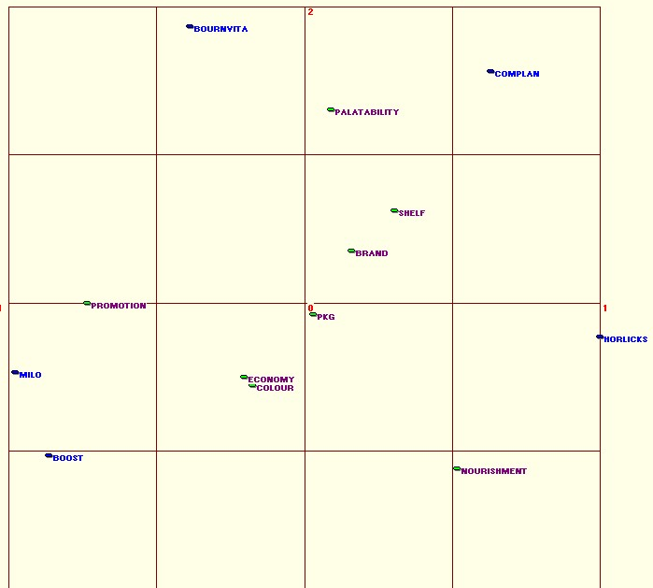

Exhibit 12
Value-Seekers Perceptual Map

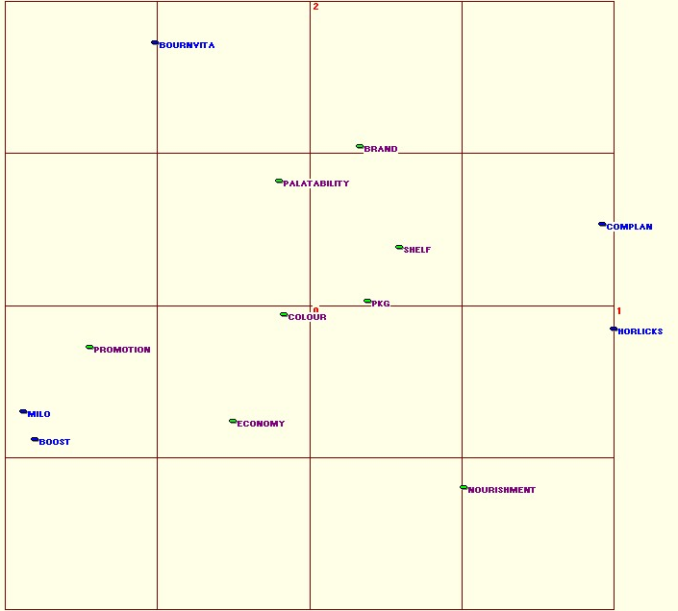

Exhibit 13
Quality-Seekers Perceptual Map

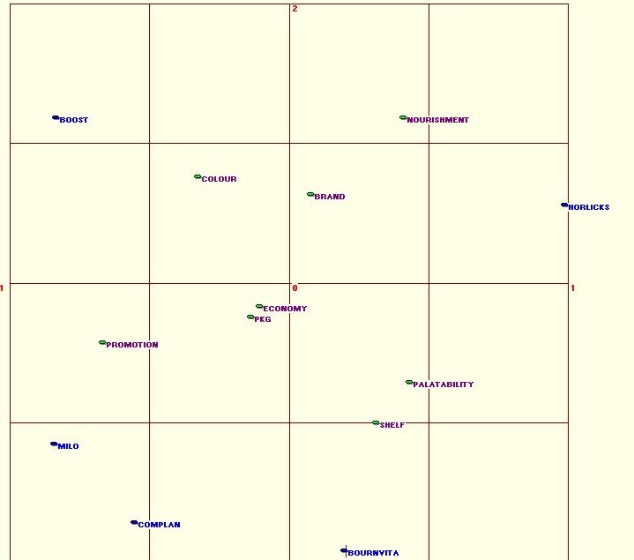

Exhibit 14
Anova test for checking brand loyalty of different brands

ANOVA

 |  | Sum of Squares | df | Mean Square | F | Sig.
Action | Between Groups | .750 | 4 | .188 | .236 | .917
Action | Within Groups | 41.285 | 52 | .794
Action | Total | 42.035 | 56
Switch | Between Groups | .139 | 4 | .035 | .093 | .984
Switch | Within Groups | 19.370 | 52 | .373
Switch | Total | 19.509 | 56

Exhibit 15
Brand Personality Map

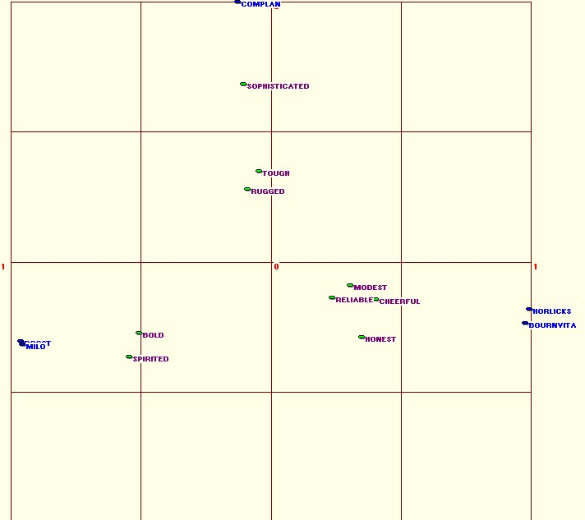

Questionnaire

Hi. We are students of IIFT. You are invited to participate in a survey to find out consumer preferences regarding various malt based health drinks available in the market today. It will take approximately 3 minutes to fill this questionnaire.

Your participation in this study is voluntary. There are no foreseeable risks associated with this project. However, if you feel uncomfortable answering any questions, you may withdraw from the survey at any point in time. It is very important for us to learn your opinions.

Your survey responses will be coded, remain strictly confidential and be reported only in the aggregate.

Thank you very much for your time and support.
You may start with the survey now.

- Is Health Drink consumed in your family?

  - Yes
  - No

- What is your age?

  - < 20 years
  - 20-32 years
  - 33-45 years
  - 46-60 years
  - > 60 years

- What is your education level?

  - Matric
  - Sr. Secondary
  - Graduate
  - Post Graduate
  - Professional Degree
  - Others

- What is the size of the family?

  - 1
  - 2
  - 3- 4
  - >4

- What is the annual average income of the family?

  - <Rs. 200,000
  - Rs. 200,000 – 400,000
  - Rs. 400,000 – 600,000
  - >Rs. 600,000

- What is the number of children in your family?

  - 0
  - 1-2
  - >2

- Which health food drink do you drink?

  - Boost
  - Bournvita
  - Complan
  - Horlicks
  - Milo

- Please rate the importance of the following purchase considerations on a scale of 1(Very unimportant) to 5 (Very Important)?
1
2
3
4
5

- Nourishment

- Colour

- Palatability

- Economy

- Shelf-presence

- Packaging

- Brand Image

- Promotions

- Please rate the following sources of information useful for purchase decision on a scale of 1 to 7?
1
2
3
4
5

  - Advertisement

  - Children

  - Doctor

  - Family

  - Past experience

  - Retailer

  - Word of mouth

- Please rate the following brands on the given attributes on a scale of 1(very poor) to 5(excellent).

 | Boost | Bournvita | Complan | Horlicks | Milo
Nourishment | ….. | ….. | ….. | ….. | …..
Colour | ….. | ….. | ….. | ….. | …..
Palatability | ….. | ….. | ….. | ….. | …..
Economy | ….. | ….. | ….. | ….. | …..
Shelf-presence | ….. | ….. | ….. | ….. | …..
Packaging | ….. | ….. | ….. | ….. | …..
Brand Image | ….. | ….. | ….. | ….. | …..
Promotions | ….. | ….. | ….. | ….. | …..

- How often do you switch health food drink?

  - Never
  - Sometimes
  - Frequently

- What do you do when your desired brand of health food drink is not available?

  - Go to another place to buy the product
  - Purchase another brand of health food drink
  - Ask the retailer to buy it for you

- Rate the following brands on the traits that they resemble on a scale of 1(No resemblance) to 5 (High Resemblance)

 | Boost | Bournvita | Complan | Horlicks | Milo
Modesty
Honesty
Cheerfulness
Boldness
Spiritedness
Reliability
Sophistication
Toughness
Ruggedness

……………………………………………………………………………………….

IX References

BOOKS and readings
Reichheld, Frederick (1966). “The Loyalty Effect”: Boston, MA: Harvard Business School Press.
Kotler, Philip (2005) "Marketing Management", Pearson Education (Eleventh Edition).
Malhotra, N.K. (2005). " Marketing Research: An Applied Orientation", Pearson Education(Fourth Edition)
Day, G.S. (1969). “A Two-Dimensional Concept of Brand Loyalty,” Journal of Consumer Research 2, 4, 241-258.
Richard I. Levin, David S Rubin(1997). "Statistics for Management", Prentice Hall of India(seventh edition)

WEBSITES
www.expresshealthcaremgmt.com/20030815/events6.html
www.indiainfoline.com/bisc/ari/impa.pdf
www.marketresearch.com/map/prod/1002524.html
www.fao.org/organicag/doc/GeneralMarketFacts.doc
www.acnielsen.ca/Insights/IntheNews/August2005.htm
www.Commerce-Database.com
www.fao.org/es/ESN/nutrition/ind-e.stm
www.expresshealthcaremgmt.com/20030430/convers.shtml
www.expresshealthcaremgmt.com/20030815/events6.shtml
www.organic.aber.ac.uk/library/Consumer%20perception%20of%20organic%20food.pdf
www.tradekey.com/ks-health-drinks
webcenter.health.webmd.netscape.com/ content/article/48/39205.htm
www.nestle.com.au/milo
www.superbrandsindia.com/superbrands2003/bournvita
superbrandsindia.com/superbrands2003/boost/index.htm

